Stigma, Barriers, and Attitudes Toward Professional Psychological Help-Seeking Among Young Czech Adults

Stigma, Barriers, and Attitudes Toward Professional Psychological Help-Seeking Among Young Czech Adults

Methods

Participants and Procedure
Participants were young Czech adults aged 18 to 35 years, recruited through an online survey distributed via social media, university networks, and snowball sampling. Data collection took place between [DATE] and [DATE]. Participation was voluntary, anonymous, and without compensation. The study was approved by [ETHICS BOARD]. Respondents who did not provide valid responses to any of the four primary scales were excluded from the respective scale analysis but retained for other analyses, consistent with full-information estimation procedures.

Statistical Analyses
Demographic and scale variables were described via frequency tables with proportions (nominal/ordinal) and mean ± SD (continuous). Group differences in scale scores between binary groups (gender, past therapy, considered-but-did-not-seek-help, pleasantness and helpfulness of therapy experience) were evaluated with Welch’s t-test and Cohen’s d. Differences across ordered categorical groups (education, town size) were evaluated with the Kruskal-Wallis H statistic and $ε^{2}$ as a rank-based effect-size index, with Holm-adjusted pairwise Wilcoxon tests for post-hoc comparisons. All comparisons are additionally visualised as violin plots with means and 95% CIs.
Internal consistency of all scales and BHSS subscales was evaluated via Cronbach’s $α$ (Cronbach, 1951), computed with 95% confidence intervals following Feldt et al. (1987), and via McDonald’s hierarchical $ω_{H}$ and total $ω_{T}$ using the psych R package (Revelle, 2022). Scales were considered adequately consistent if $α$ exceeded 0.70.
The correlational structure among all scale sum scores, age, and help-seeking indicators was explored using Spearman’s $ρ$, which is robust to the bounded, typically skewed distribution of Likert sum scores.
To address RQ1, scales’ scores were compared between sexes, education levels, town sizes, and conditional on past therapy experience, consideration of seeking therapy (considered-to-seek-help status), and presence of mental disorder in self or family. Furthermore, within the sample of participants who underwent therapy, further comparisons were conducted between those that considered it a pleasant or helpful experience, and the type of professional the participants visited (psychotherapist or psychologist). Given the descriptive nature of RQ1, no formal statistical modelling was performed.
To address RQ2, we fitted a structural equation model (SEM) based on the Internalized Stigma Model (Vogel et al., 2007), in which public stigma (PSOSH) exerts its effect on self-stigma (SSOSH) which directly acts upon the willingness to seek support via affecting the attitudes toward help-seeking (ATSPPH-SF). Moreover, perceived barriers (BHSS) were considered as a separate mediator of the effect of stigma perception on the willingness to seek help, parallel to the ATSPPH-SF pathway. While the original model assumes that the direct effect of PSOSH on ATSPPH-SF is negligible, it remains unclear whether the same holds for the direct effect of PSOSH on BHSS. Consequently, we estimated both direct and indirect effects (Figure 1). Each endogenous variable was further regressed on gender, age and education as potential confounders (Figure A1). Finally, residual covariance bewtween ATSPP-SF and BHSS was allowed to vary. Since the willingness to seek support was not directly measured, we focus on estimating the direct and indirect path strengths between stigma variables (PSOSH, SOSH) and their mediators, attitudes towards help-seeking (ATSPP-SF) and perceived barriers (BHSS). To test gender moderation (RQ3), the path model was refitted as a multi-group SEM with gender as the grouping variable.
The model was estimated in lavaan (Rosseel, 2012) with the maximum-likelihood estimator using full-information maximum likelihood (FIML) to handle missing data under the assumption that data are missing at random (MAR). Indirect effects and their 95% percentile bootstrap confidence intervals were estimated from 2,000 bootstrap replications. Because the model includes direct paths from PSOSH to both ATSPPH-SF and BHSS alongside the indirect pathways, it is exactly identified (i.e., saturated, df = 0). Global fit indices are therefore trivially perfect regardless of the data and non-informative. Instead, inference was based exclusively on the structural parameter estimates and their bootstrap confidence intervals.
All analyses were conducted in R (version 4.6.1). The complete model specification, and analysis code are available at https://github.com/josefmana/stighelp.git.

Results

Sample Description
In total, the sample comprised 3078 young Czech adults (mean age 26.08 ± 4.82 years, range 18–35). There were 2908 women (94.5%), and 158 men (5.1%). In terms of educational attainment, 151 finished elementary school only, 1387 participants held a high-school diploma, 760 a Bachelor’s degree, 762 a Master’s degree, and 18 a doctoral degree. Full demographic and scale descriptive statistics are presented in Table A1.
62.6% of participants reported having previously sought professional psychological help from a psychologist or psychotherapist, while 37.4% had not. Among those who had never sought help, 31.8% reported having considered doing so at some point but ultimately not pursuing it. The distribution of help-seeking indicators, type of provider consulted, and experience ratings are presented in Table A2.

Scales Internal Consistency
Scale descriptive statistics are presented in Table 1. All scales demonstrated adequate internal consistency in the current sample. Standardized Cronbach’s $α$ estimates were 0.87 for PSOSH, 0.82 for SSOSH, 0.73 for ATSPPH-SF, and 0.88 for the BHSS total score. Internal consistency estimates for all BHSS subscales and McDonald’s $ω$ are reported in Table 2.

Correlational Structure
Spearman correlation coefficients among scale sum scores and key covariates are presented in Table 3. Public stigma (PSOSH) and self-stigma (SSOSH) were positively and significantly correlated with each other and with BHSS total and all BHSS subscales, and negatively correlated with ATSPPH-SF. Age and education showed comparatively weaker associations with the scale scores.

Group Differences
Full numeric results for all scales and grouping variables are in Table A3. Figure 2 and Figure A2 show distributions and means. Figure A3 shows comparisons of participants who underwent therapy in the past by their subjective experience.

Gender
Men reported significantly higher self-stigma ($M_{\text{women}}$ = 22.24, $M_{\text{men}}$ = 24.19; t(160.5) = 3.20, p = .002, d = 0.31), but not significantly higher public stigma ($M_{\text{women}}$ = 10.05, $M_{\text{men}}$ = 10.11; t(175.2) = 0.19, p = .847, d = 0.02) compared to women. Women reported significantly more positive attitudes toward help-seeking ($M_{\text{women}}$ = 31.61, $M_{\text{men}}$ = 29.62; t(129.1) = -3.93, p < .001, d = -0.46). Gender differences on the BHSS total score were not statistically significant ($M_{\text{women}}$ = 90.47, $M_{\text{men}}$ = 92.48; t(145.5) = 1.28, p = .202, d = 0.11).

Therapy Experience
Participants with prior therapy experience reported significantly lower self-stigma ($M_{\text{no}}$ = 24.04, $M_{\text{yes}}$ = 21.34; t(2283.3) = -11.20, p < .001, d = -0.43), more positive help-seeking attitudes ($M_{\text{no}}$ = 30.23, $M_{\text{yes}}$ = 32.24; t(1692.9) = 10.90, p < .001, d = 0.48), and less perceived barriers towards help-seeking ($M_{\text{no}}$ = 95.07, $M_{\text{yes}}$ = 87.97; t(1966.3) = -9.33, p < .001, d = -0.38) than those without prior experience. No statistically significant difference was observed regarding public stigma ($M_{\text{no}}$ = 9.92, $M_{\text{yes}}$ = 10.13; t(2547.10) = 1.50, p = .133, d = 0.06).
Among those with prior therapy experience, both pleasantness and perceived helpfulness of the therapy experience were generally associated with less stigma, less perceived barriers, and more favorable attitudes towards help-seeking (Figure A3, Table A3).

Help-Seeking Consideration
Compared to participants who had never considered seeking professional help, those who had considered pursuing it showed significantly higher self-stigma (t(1122.0) = 8.82, p < .001, d = 0.38), public stigma (t(1218.5) = 5.24, p < .001, d = 0.22), and perceived barriers (t(961.5) = 14.28, p < .001, d = 0.66), as well as less favorable attitudes towards seeking help (t(940.9) = -11.37, p < .001, d = -0.54).

Education and City Size
Relationships between both education level and city size, and all measured psychological constructs were detected. Higher education and larger city size were associated with less public and self-stigma, less perceived barriers, and more favorable attitudes toward help-seeking (see Figure A2 and Table A3)

Mediation Analysis: Attitudes and Barriers as Parallel Mediators
The path model is exactly identified (df = 0), including both indirect pathways via SSOSH and direct paths from PSOSH to each outcome exhausts all model degrees of freedom, so global fit statistics are trivially perfect and uninformative. Inference is therefore based on the structural parameter estimates and their bootstrap confidence intervals.
The direct effect of public stigma on self-stigma was $β$ = 0.36, 95% CI [0.32, 0.40]. The direct effect of self-stigma on attitudes was $β$ = -0.53, 95% CI [-0.57, -0.49], and the direct effect of self-stigma on barriers was $β$ = 0.58, 95% CI [0.54, 0.60]. The indirect effect of PSOSH on ATSPPH-SF via SSOSH was $β$ = -0.192, 95% CI [-0.22, -0.17], whereas the equivalent effect on BHSS was $β$ = 0.21, 95% CI [0.18, 0.23]. These findings are consistent with the Internalized Stigma Model’s assumption that public stigma exerts its influence on attitudes towards help-seeking behavior via the internalization of stigmatizing beliefs. Full parameter estimates excluding covariate effects are presented in Table 4 (see Table A4 for estimates including covariate effects).

Gender Moderation of the Mediation Structure
Model parameters of the gender moderation model are presented in Table A5. Overall, the primary findings of the main model hold in the gender-specific submodels.

Table 1
Scale sum-score descriptive statistics
Scale | N | M | SD | Min | Max | Skew | Kurtosis
PSOSH | 3068 | 10.06 | 3.74 | 5 | 25 | 0.93 | 0.81
SSOSH | 2877 | 22.35 | 6.40 | 10 | 46 | 0.42 | -0.06
ATSPPH-SF | 2297 | 31.50 | 4.32 | 13 | 40 | -0.76 | 0.72
BHSS | 2445 | 90.59 | 18.74 | 34 | 145 | 0.02 | -0.28
BHSS (self-control) | 2458 | 30.16 | 6.50 | 10 | 50 | 0.08 | 0.19
BHSS (resignation) | 2457 | 17.57 | 6.47 | 6 | 30 | -0.03 | -0.92
BHSS (distrust) | 2459 | 15.14 | 4.22 | 6 | 30 | 0.17 | -0.40
BHSS (privacy) | 2458 | 15.71 | 4.41 | 5 | 25 | -0.21 | -0.53
BHSS (emotional control) | 2464 | 12.01 | 4.42 | 4 | 20 | -0.07 | -0.97
M: mean; SD: standard deviation; Skew: Pearson's skewness; Kurtosis: excess kurtosis. PSOSH: Perceptions of Stigmatization by Others for Seeking Help; SSOSH: Self-Stigma of Seeking Help; ATSPPH-SF: Attitudes Toward Seeking Professional Psychological Help; BHSS: Barriers to Help-Seeking Scale.

Table 2
Cronbach’s alpha and McDonald’s omega for all scales and subscales
Scale | Items | α (raw) | α (std.) | r̄ | ωH | ωT
PSOSH | 5 | 0.87 | 0.87 | 0.58 | 0.88 | 0.88
SSOSH | 10 | 0.81 | 0.82 | 0.31 | 0.82 | 0.82
BHSS | 31 | 0.89 | 0.88 | 0.20 | 0.86 | 0.89
ATSPPH-SF | 10 | 0.72 | 0.73 | 0.21 | 0.74 | 0.74
BHSS (self-control) | 10 | 0.76 | 0.76 | 0.25 | — | —
BHSS (resignation) | 6 | 0.88 | 0.88 | 0.55 | — | —
BHSS (distrust) | 6 | 0.57 | 0.57 | 0.18 | — | —
BHSS (privacy) | 5 | 0.69 | 0.69 | 0.31 | — | —
BHSS (emotional control) | 4 | 0.83 | 0.83 | 0.55 | — | —
α: Cronbach's alpha; r̄: mean inter-item correlation; ωH: hierarchical omega (general factor saturation); ωT: total omega.

Table 3
Spearman correlations among scale sum scores, age, and help-seeking indicators
 | PSOSH | SSOSH | ATSPPH-SF | BHSS (self-control) | BHSS (resignation) | BHSS (distrust) | BHSS (privacy) | BHSS (emotional control) | Age | Gender | Education | Past therapy | Thought of therapy
PSOSH | 1.00
SSOSH | 0.38 | 1.00
ATSPPH-SF | -0.24 | -0.54 | 1.00
BHSS (self-control) | 0.33 | 0.55 | -0.42 | 1.00
BHSS (resignation) | 0.13 | 0.43 | -0.48 | 0.28 | 1.00
BHSS (distrust) | 0.27 | 0.34 | -0.48 | 0.30 | 0.35 | 1.00
BHSS (privacy) | 0.32 | 0.46 | -0.42 | 0.48 | 0.37 | 0.40 | 1.00
BHSS (emotional control) | 0.29 | 0.46 | -0.39 | 0.43 | 0.36 | 0.33 | 0.62 | 1.00
Age | -0.03 | -0.09 | 0.13 | -0.07 | -0.12 | -0.15 | -0.14 | -0.10 | 1.00
Gender | 0.01 | 0.06 | -0.08 | 0.04 | 0.02 | 0.00 | -0.01 | -0.00 | -0.04 | 1.00
Education | -0.07 | -0.10 | 0.13 | -0.09 | -0.07 | -0.17 | -0.14 | -0.14 | 0.59 | -0.05 | 1.00
Past therapy | 0.02 | -0.21 | 0.24 | -0.04 | -0.26 | -0.15 | -0.10 | -0.10 | 0.01 | -0.02 | 0.02 | 1.00
Thought of therapy | 0.09 | 0.16 | -0.24 | 0.11 | 0.26 | 0.27 | 0.16 | 0.18 | -0.08 | -0.08 | -0.05 | -0.15 | 1.00
Lower triangle: Spearman's ρ. Blank cells: not significantly different from zero at p < .05 (two-sided, Holm-corrected). PSOSH: public stigma; SSOSH: self-stigma; ATSPPH-SF: attitudes toward help-seeking; BHSS: barriers.

Table 4
SEM parameter estimates (excluding covariates effects)
Independent variable | Mediator | Dependent variable | β | B | SE | 95% CI | p
Direct effects
PSOSH → | — | SSOSH | 0.36 | 0.36 | 0.02 | [0.32, 0.40] | < .001 | ***
SSOSH → | — | ATSPPH-SF | -0.53 | -0.53 | 0.02 | [-0.57, -0.49] | < .001 | ***
SSOSH → | — | BHSS | 0.58 | 0.57 | 0.02 | [0.54, 0.60] | < .001 | ***
PSOSH → | — | ATSPPH-SF | -0.05 | -0.05 | 0.02 | [-0.09, -0.01] | .015 | *
PSOSH → | — | BHSS | 0.15 | 0.15 | 0.02 | [0.11, 0.18] | < .001 | ***
Indirect effects
PSOSH → | SSOSH → | ATSPPH-SF | 0.36 × -0.53 = -0.19 | -0.19 | 0.01 | [-0.22, -0.17] | < .001 | ***
PSOSH → | SSOSH → | BHSS | 0.36 × 0.58 = 0.21 | 0.21 | 0.01 | [0.18, 0.23] | < .001 | ***
Direct effects: β = fully standardised path coefficient; B = unstandardised estimate; SE = bootstrap SE; CI = percentile 95% CI. Indirect effects: β shown as product of standardised component paths. PSOSH: public stigma; SSOSH: self-stigma; ATSPPH-SF: attitudes toward help-seeking; BHSS: barriers to help-seeking. *p < .05; **p < .01; ***p < .001.

Figure 1
Directed acyclic graph depicting the hypothesized causal structure. Public stigma (PSOSH) influences attitudes toward help-seeking (ATSPPH-SF) and barriers (BHSS) both directly and indirectly via self-stigma (SSOSH). Help seeking behavior is the final outcome which was not measured in this study. Gender, education and age act as exogenous covariates on all endogenous nodes but are excluded from this depiction for clarity.
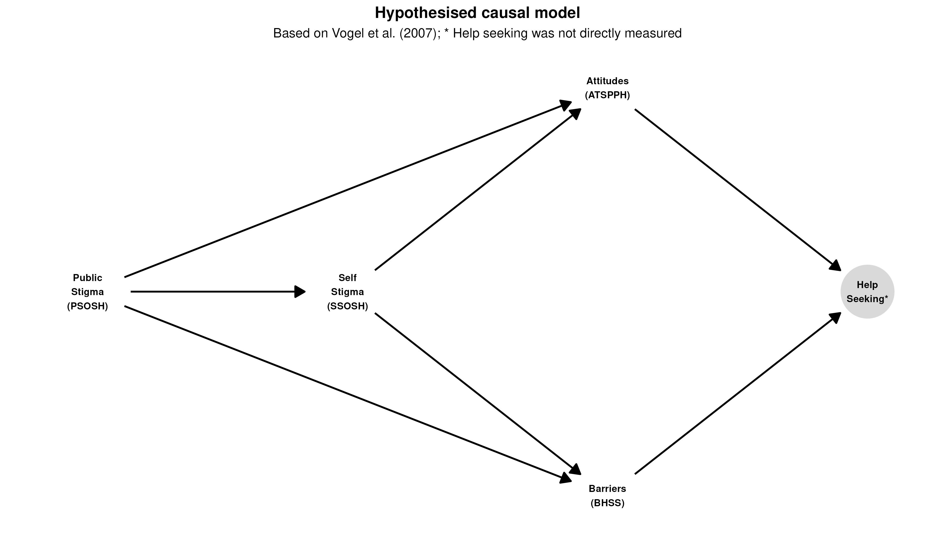

Figure 2
Scale distributions by binary grouping variables. Violin shape shows the full distribution; point = mean; range = 95% CI. Significance from Welch t-tests (p < .001, p < .01, p < .05, ns).
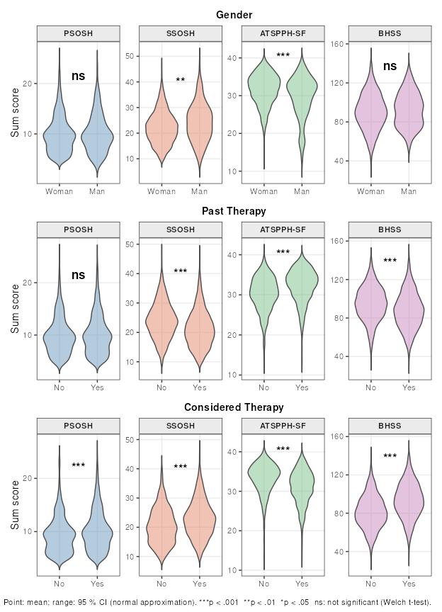

Appendix

Appendix

Figure A1
Directed acyclic graph depicting the hypothesized causal structure. Public stigma (PSOSH) influences attitudes toward help-seeking (ATSPPH-SF) and barriers (BHSS) both directly and indirectly via self-stigma (SSOSH). Help seeking behavior is the final outcome which was not measured in this study. Gender, education and age act as exogenous covariates on all endogenous nodes.
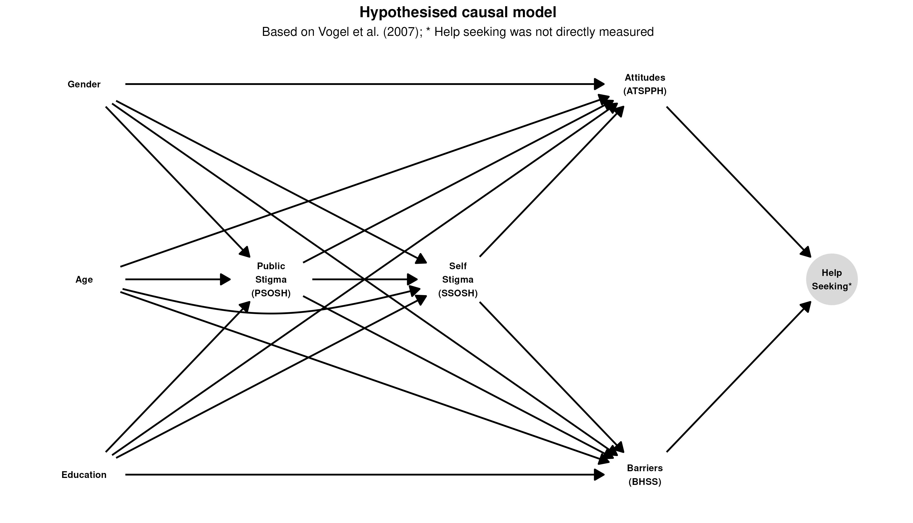

Table A1
Demographic characteristics of the sample
Category | n | %
Gender
Woman | 2908 | 94.5
Man | 158 | 5.1
NA | 12 | 0.4
Education
Elementary school | 151 | 4.9
High school | 1387 | 45.1
Bachelors | 760 | 24.7
Masters | 762 | 24.8
PhD | 18 | 0.6
Town size
< 5,000 inhabitants | 843 | 27.4
5,000 - 50,000 inhabitants | 720 | 23.4
50,000 - 100,000 inhabitants | 259 | 8.4
> 100,000 inhabitants | 1256 | 40.8
Therapy-related variables are reported in Table 3.

Table A2
Help-seeking patterns.
Category | n | %
Past therapy
No | 1150 | 37.4
Yes | 1924 | 62.6
Thought of therapy
No | 697 | 22.8
Yes | 2362 | 77.2
Chosen one
Psychologist | 954 | 39.0
Psychotherapist | 1493 | 61.0
Mental disorder (self)
Yes | 774 | 25.1
No | 2273 | 73.8
Undisclosed | 31 | 1.0
Mental disorder (family)
Yes | 2147 | 69.8
No | 914 | 29.7
Undisclosed | 17 | 0.6
Therapy (family)
No | 681 | 24.7
Yes | 2075 | 75.3

Table A3
Group comparisons.
Scale | n (0) | n (1) | M (0) | M (1) | Statistic | Effect size | p
Gender
PSOSH | 2898 | 158 | 10.05 | 10.11 | t(175.2) = 0.193 | d = 0.016 | .847
SSOSH | 2717 | 149 | 22.24 | 24.19 | t(160.5) = 3.203 | d = 0.306 | .002 | **
ATSPPH-SF | 2167 | 122 | 31.61 | 29.62 | t(129.1) = -3.931 | d = -0.463 | < .001 | ***
BHSS | 2307 | 129 | 90.47 | 92.48 | t(145.5) = 1.282 | d = 0.107 | .202
BHSS (self-control) | 2319 | 130 | 30.08 | 31.44 | t(143.2) = 2.284 | d = 0.210 | .024 | *
BHSS (resignation) | 2318 | 130 | 17.55 | 18.13 | t(147.7) = 1.104 | d = 0.090 | .271
BHSS (distrust) | 2320 | 130 | 15.14 | 15.25 | t(145.5) = 0.305 | d = 0.026 | .761
BHSS (privacy) | 2320 | 129 | 15.70 | 15.60 | t(141.3) = -0.234 | d = -0.022 | .815
BHSS (emotional control) | 2325 | 130 | 12.01 | 11.94 | t(144.3) = -0.176 | d = -0.016 | .860
Past therapy
PSOSH | 1147 | 1917 | 9.92 | 10.13 | t(2547.1) = 1.504 | d = 0.055 | .133
SSOSH | 1067 | 1806 | 24.04 | 21.34 | t(2283.3) = -11.199 | d = -0.430 | < .001 | ***
ATSPPH-SF | 835 | 1458 | 30.23 | 32.24 | t(1692.9) = 10.898 | d = 0.477 | < .001 | ***
BHSS | 894 | 1547 | 95.07 | 87.97 | t(1966.3) = -9.330 | d = -0.385 | < .001 | ***
BHSS (self-control) | 901 | 1553 | 30.51 | 29.94 | t(1814.2) = -2.096 | d = -0.089 | .036 | *
BHSS (resignation) | 897 | 1556 | 19.77 | 16.31 | t(2135.8) = -13.840 | d = -0.554 | < .001 | ***
BHSS (distrust) | 899 | 1556 | 15.94 | 14.68 | t(1942.5) = -7.273 | d = -0.301 | < .001 | ***
BHSS (privacy) | 899 | 1555 | 16.27 | 15.38 | t(1886.6) = -4.867 | d = -0.203 | < .001 | ***
BHSS (emotional control) | 901 | 1559 | 12.59 | 11.67 | t(1945.8) = -5.023 | d = -0.208 | < .001 | ***
Thought of therapy
PSOSH | 694 | 2355 | 9.43 | 10.23 | t(1218.5) = 5.236 | d = 0.216 | < .001 | ***
SSOSH | 662 | 2197 | 20.48 | 22.90 | t(1122) = 8.817 | d = 0.384 | < .001 | ***
ATSPPH-SF | 525 | 1759 | 33.25 | 30.99 | t(940.9) = -11.373 | d = -0.535 | < .001 | ***
BHSS | 554 | 1875 | 81.32 | 93.32 | t(961.5) = 14.283 | d = 0.664 | < .001 | ***
BHSS (self-control) | 554 | 1888 | 28.91 | 30.52 | t(1003.7) = 5.523 | d = 0.250 | < .001 | ***
BHSS (resignation) | 556 | 1884 | 14.52 | 18.48 | t(947) = 13.482 | d = 0.633 | < .001 | ***
BHSS (distrust) | 556 | 1886 | 13.01 | 15.76 | t(987) = 14.780 | d = 0.676 | < .001 | ***
BHSS (privacy) | 556 | 1885 | 14.35 | 16.10 | t(946.5) = 8.541 | d = 0.401 | < .001 | ***
BHSS (emotional control) | 556 | 1891 | 10.53 | 12.44 | t(960.5) = 9.431 | d = 0.438 | < .001 | ***
Pleasant experience
PSOSH | 513 | 1266 | 10.67 | 9.80 | t(896.6) = -4.321 | d = -0.232 | < .001 | ***
SSOSH | 480 | 1195 | 23.70 | 20.29 | t(805.7) = -9.725 | d = -0.550 | < .001 | ***
ATSPPH-SF | 400 | 956 | 30.19 | 33.19 | t(636.9) = 11.717 | d = 0.755 | < .001 | ***
BHSS | 420 | 1019 | 96.10 | 83.98 | t(753) = -11.330 | d = -0.668 | < .001 | ***
BHSS (self-control) | 422 | 1023 | 31.84 | 29.06 | t(736.8) = -7.461 | d = -0.445 | < .001 | ***
BHSS (resignation) | 422 | 1025 | 17.55 | 15.61 | t(777.5) = -5.088 | d = -0.296 | < .001 | ***
BHSS (distrust) | 421 | 1026 | 16.34 | 13.77 | t(731.4) = -10.519 | d = -0.628 | < .001 | ***
BHSS (privacy) | 420 | 1026 | 17.12 | 14.57 | t(773.5) = -10.325 | d = -0.600 | < .001 | ***
BHSS (emotional control) | 422 | 1028 | 13.24 | 10.96 | t(756.4) = -8.847 | d = -0.520 | < .001 | ***
Helpful experience
PSOSH | 468 | 1311 | 10.26 | 9.98 | t(778.4) = -1.337 | d = -0.074 | .182
SSOSH | 433 | 1242 | 22.97 | 20.67 | t(722.4) = -6.379 | d = -0.365 | < .001 | ***
ATSPPH-SF | 356 | 1000 | 29.39 | 33.34 | t(534.2) = 15.231 | d = 1.032 | < .001 | ***
BHSS | 379 | 1060 | 94.73 | 84.93 | t(674.4) = -8.926 | d = -0.531 | < .001 | ***
BHSS (self-control) | 381 | 1064 | 31.29 | 29.37 | t(629.1) = -4.925 | d = -0.305 | < .001 | ***
BHSS (resignation) | 380 | 1067 | 17.77 | 15.60 | t(667.6) = -5.527 | d = -0.330 | < .001 | ***
BHSS (distrust) | 381 | 1066 | 16.70 | 13.74 | t(687.4) = -12.424 | d = -0.731 | < .001 | ***
BHSS (privacy) | 380 | 1066 | 16.33 | 14.95 | t(674) = -5.319 | d = -0.316 | < .001 | ***
BHSS (emotional control) | 381 | 1069 | 12.66 | 11.26 | t(660) = -5.209 | d = -0.313 | < .001 | ***
Education
PSOSH | --- | --- | --- | --- | H(4) = 21.847 | ε² = 0.007 | < .001 | ***
SSOSH | --- | --- | --- | --- | H(4) = 30.834 | ε² = 0.011 | < .001 | ***
ATSPPH-SF | --- | --- | --- | --- | H(4) = 48.979 | ε² = 0.021 | < .001 | ***
BHSS | --- | --- | --- | --- | H(4) = 70.242 | ε² = 0.029 | < .001 | ***
BHSS (self-control) | --- | --- | --- | --- | H(4) = 24.777 | ε² = 0.01 | < .001 | ***
BHSS (resignation) | --- | --- | --- | --- | H(4) = 16.751 | ε² = 0.007 | .002 | **
BHSS (distrust) | --- | --- | --- | --- | H(4) = 76.292 | ε² = 0.031 | < .001 | ***
BHSS (privacy) | --- | --- | --- | --- | H(4) = 52.309 | ε² = 0.021 | < .001 | ***
BHSS (emotional control) | --- | --- | --- | --- | H(4) = 51.850 | ε² = 0.021 | < .001 | ***
Town size
PSOSH | --- | --- | --- | --- | H(3) = 39.317 | ε² = 0.013 | < .001 | ***
SSOSH | --- | --- | --- | --- | H(3) = 38.517 | ε² = 0.013 | < .001 | ***
ATSPPH-SF | --- | --- | --- | --- | H(3) = 12.883 | ε² = 0.006 | .005 | **
BHSS | --- | --- | --- | --- | H(3) = 44.270 | ε² = 0.018 | < .001 | ***
BHSS (self-control) | --- | --- | --- | --- | H(3) = 8.428 | ε² = 0.003 | .038 | *
BHSS (resignation) | --- | --- | --- | --- | H(3) = 17.980 | ε² = 0.007 | < .001 | ***
BHSS (distrust) | --- | --- | --- | --- | H(3) = 59.540 | ε² = 0.024 | < .001 | ***
BHSS (privacy) | --- | --- | --- | --- | H(3) = 29.845 | ε² = 0.012 | < .001 | ***
BHSS (emotional control) | --- | --- | --- | --- | H(3) = 20.002 | ε² = 0.008 | < .001 | ***
t: Welch's t; d: Cohen's d; H: Kruskal-Wallis H; ε²: epsilon-squared. For binary groupvars: 0 = reference category label is the groupvar name (e.g. No / Woman / Unpleasant / Unhelpful), 1 = contrast. *p < .05, **p < .01, ***p < .001.

Figure A2
Scale distributions by ordinal grouping variables. Point = mean; range = 95% CI. KW: overall Kruskal-Wallis significance; post-hoc pairwise results in Table 6.
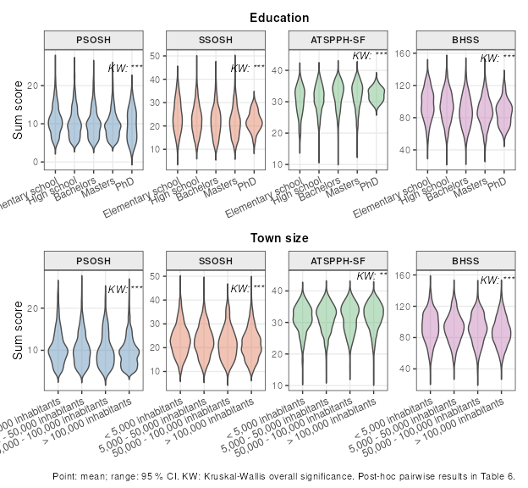

Figure A3
Scale distributions by therapy experience (past-therapy subsample only). Point = mean; range = 95% CI. Significance from Welch t-tests (p < .001, p < .01, p < .05, ns).
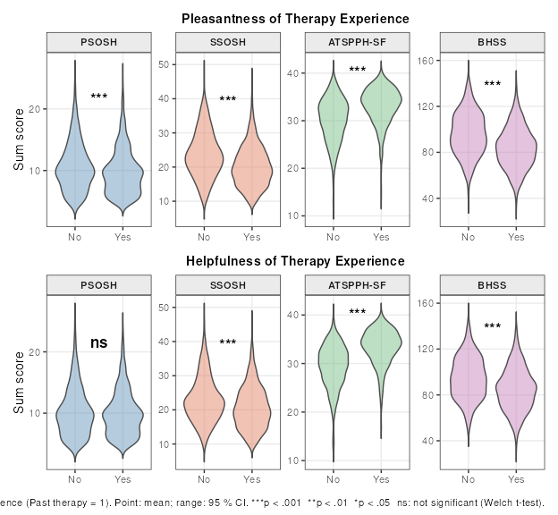

Table A4
SEM parameter estimates including covariate effects
Independent variable | Mediator | Dependent variable | β | B | SE | 95% CI | p
Direct effects
PSOSH → | — | SSOSH | 0.36 | 0.36 | 0.02 | [0.32, 0.40] | < .001 | ***
SSOSH → | — | ATSPPH-SF | -0.53 | -0.53 | 0.02 | [-0.57, -0.49] | < .001 | ***
SSOSH → | — | BHSS | 0.58 | 0.57 | 0.02 | [0.54, 0.60] | < .001 | ***
PSOSH → | — | ATSPPH-SF | -0.05 | -0.05 | 0.02 | [-0.09, -0.01] | .015 | *
PSOSH → | — | BHSS | 0.15 | 0.15 | 0.02 | [0.11, 0.18] | < .001 | ***
Indirect effects
PSOSH → | SSOSH → | ATSPPH-SF | 0.36 × -0.53 = -0.19 | -0.19 | 0.01 | [-0.22, -0.17] | < .001 | ***
PSOSH → | SSOSH → | BHSS | 0.36 × 0.58 = 0.21 | 0.21 | 0.01 | [0.18, 0.23] | < .001 | ***
Covariates → SSOSH
Age → | — | SSOSH | -0.07 | -0.07 | 0.02 | [-0.12, -0.03] | < .001 | ***
Gender → | — | SSOSH | 0.06 | 0.28 | 0.09 | [0.11, 0.45] | .001 | **
Education → | — | SSOSH | -0.02 | -0.02 | 0.02 | [-0.06, 0.02] | .297
Covariates → ATSPPH-SF
Age → | — | ATSPPH-SF | 0.06 | 0.06 | 0.02 | [0.01, 0.10] | .008 | **
Gender → | — | ATSPPH-SF | -0.07 | -0.30 | 0.09 | [-0.48, -0.12] | .001 | **
Education → | — | ATSPPH-SF | 0.02 | 0.02 | 0.02 | [-0.02, 0.06] | .335
Covariates → BHSS
Age → | — | BHSS | -0.07 | -0.07 | 0.02 | [-0.11, -0.04] | < .001 | ***
Gender → | — | BHSS | -0.02 | -0.08 | 0.06 | [-0.20, 0.02] | .135
Education → | — | BHSS | -0.04 | -0.04 | 0.02 | [-0.08, -0.00] | .050 | *
Covariates → PSOSH
Age → | — | PSOSH | 0.03 | 0.03 | 0.02 | [-0.01, 0.08] | .144
Gender → | — | PSOSH | -0.00 | -0.00 | 0.08 | [-0.16, 0.16] | .988
Education → | — | PSOSH | -0.10 | -0.10 | 0.02 | [-0.14, -0.06] | < .001 | ***
Direct effects: β = fully standardised path coefficient; B = unstandardised estimate; SE = bootstrap SE; CI = percentile 95% CI. Indirect effects: β shown as product of standardised component paths. PSOSH: public stigma; SSOSH: self-stigma; ATSPPH-SF: attitudes toward help-seeking; BHSS: barriers to help-seeking. *p < .05; **p < .01; ***p < .001.

Table A5
Gender-moderation SEM
Independent variable | Mediator | Dependent variable | β | B | SE | 95% CI | p
Women
PSOSH → | — | SSOSH | 0.36 | 0.36 | 0.02 | [0.32, 0.40] | < .001 | ***
SSOSH → | — | ATSPPH-SF | -0.53 | -0.52 | 0.02 | [-0.55, -0.48] | < .001 | ***
SSOSH → | — | BHSS | 0.57 | 0.58 | 0.02 | [0.54, 0.61] | < .001 | ***
PSOSH → | — | ATSPPH-SF | -0.06 | -0.06 | 0.02 | [-0.10, -0.02] | .009 | **
PSOSH → | — | BHSS | 0.15 | 0.15 | 0.02 | [0.11, 0.18] | < .001 | ***
PSOSH → | SSOSH → | ATSPPH-SF | 0.36 × -0.53 = -0.19 | -0.19 | 0.01 | [-0.21, -0.16] | < .001 | ***
PSOSH → | SSOSH → | BHSS | 0.36 × 0.57 = 0.21 | 0.21 | 0.01 | [0.18, 0.23] | < .001 | ***
Age → | — | SSOSH | -0.07 | -0.07 | 0.02 | [-0.11, -0.03] | .002 | **
Education → | — | SSOSH | -0.03 | -0.02 | 0.02 | [-0.07, 0.02] | .243
Age → | — | ATSPPH-SF | 0.05 | 0.04 | 0.02 | [0.00, 0.08] | .035 | *
Education → | — | ATSPPH-SF | 0.04 | 0.04 | 0.02 | [-0.00, 0.08] | .060
Age → | — | BHSS | -0.07 | -0.07 | 0.02 | [-0.11, -0.03] | < .001 | ***
Education → | — | BHSS | -0.04 | -0.04 | 0.02 | [-0.08, 0.00] | .045 | *
Age → | — | PSOSH | 0.04 | 0.04 | 0.02 | [-0.01, 0.09] | .073
Education → | — | PSOSH | -0.11 | -0.11 | 0.02 | [-0.15, -0.06] | < .001 | ***
Men
PSOSH → | — | SSOSH | 0.34 | 0.40 | 0.10 | [0.19, 0.59] | < .001 | ***
SSOSH → | — | ATSPPH-SF | -0.60 | -0.66 | 0.09 | [-0.84, -0.47] | < .001 | ***
SSOSH → | — | BHSS | 0.64 | 0.50 | 0.05 | [0.41, 0.60] | < .001 | ***
PSOSH → | — | ATSPPH-SF | 0.06 | 0.08 | 0.11 | [-0.15, 0.31] | .501
PSOSH → | — | BHSS | 0.15 | 0.14 | 0.07 | [0.01, 0.27] | .040 | *
PSOSH → | SSOSH → | ATSPPH-SF | 0.34 × -0.60 = -0.21 | -0.26 | 0.08 | [-0.43, -0.12] | < .001 | ***
PSOSH → | SSOSH → | BHSS | 0.34 × 0.64 = 0.22 | 0.20 | 0.05 | [0.09, 0.31] | < .001 | ***
Age → | — | SSOSH | -0.13 | -0.16 | 0.12 | [-0.38, 0.07] | .159
Education → | — | SSOSH | 0.01 | 0.01 | 0.12 | [-0.22, 0.24] | .940
Age → | — | ATSPPH-SF | 0.19 | 0.26 | 0.10 | [0.05, 0.46] | .012 | *
Education → | — | ATSPPH-SF | -0.22 | -0.30 | 0.11 | [-0.50, -0.08] | .006 | **
Age → | — | BHSS | -0.11 | -0.11 | 0.08 | [-0.26, 0.04] | .148
Education → | — | BHSS | 0.01 | 0.01 | 0.07 | [-0.13, 0.17] | .854
Age → | — | PSOSH | -0.11 | -0.11 | 0.11 | [-0.33, 0.11] | .312
Education → | — | PSOSH | 0.05 | 0.05 | 0.10 | [-0.16, 0.25] | .602
Gender differences (Men − Women)
PSOSH → | SSOSH → | ATSPPH-SF | -0.02 | -0.08 | 0.08 | [-0.24, 0.06] | .321
PSOSH → | SSOSH → | BHSS | 0.01 | -0.01 | 0.06 | [-0.12, 0.11] | .900
Configural model (all paths estimated freely within each gender group). Direct effects: β = fully standardised coefficient. Gender differences: β = Men − Women unstandardised indirect difference. PSOSH: public stigma; SSOSH: self-stigma; ATSPPH-SF: attitudes toward help-seeking; BHSS: barriers. *p < .05; **p < .01; ***p < .001.

References
Cronbach, L. J. (1951). Coefficient alpha and the internal structure of tests. Psychometrika, 16(3), 297–334. https://doi.org/10.1007/bf02310555
Feldt, L. S., Woodruff, D. J., & Salih, F. A. (1987). Statistical inference for coefficient alpha. Applied Psychological Measurement, 11(1), 93–103. https://doi.org/10.1177/014662168701100107
Revelle, W. (2022). Psych: Procedures for psychological, psychometric, and personality research. https://CRAN.R-project.org/package=psych
Rosseel, Y. (2012). lavaan: An R package for structural equation modeling. In Journal of Statistical Software (No. 2; Vol. 48, pp. 1–36). https://doi.org/10.18637/jss.v048.i02
Vogel, D. L., Wade, N. G., & Hackler, A. H. (2007). Perceived public stigma and the willingness to seek counseling: The mediating roles of self-stigma and attitudes toward counseling. Journal of Counseling Psychology, 54(1), 40–50. https://doi.org/10.1037/0022-0167.54.1.40

