Well being statistics

Josef Mana
Department of Cognitive Psychology, Institute of Psychology, Czech Academy of Sciences

Author Note
Josef Mana  https://orcid.org/0000-0002-7817-3978
Correspondence concerning this article should be addressed to Josef Mana, Department of Cognitive Psychology, Institute of Psychology, Czech Academy of Sciences, Pod Vodárenskou věží 4, Prague 18200, Czech Republic

Well being statistics

Methods

Statistical analyses
All demographic and outcome variables were described via contingency tables for nominal (gender and education level), and ordinal (single item responses) variables and via sample mean ± standard deviation for continuous variables (age, years of teaching experience and questionnaires’ sum scores). All descriptive statistics were computed separately for each city size. Furthermore, null distributions of nominal and ordinal variables across city sizes were tested via Pearson’s $χ^{2}$ test of the null hypothesis that the joint distribution of the cell counts is the product of the row and column marginals. The null hypotheses of zero difference between means of continuous variables across city sizes as well as across education levels were tested via one-way ANOVAs with Type I sum of squares. The null hypotheses of zero difference between means of continuous variables in men and women were tested via two sample t-test with Welch approximation of degrees of freedom and two-sided alternative hypothesis. Age was kept continuous rather than binned; its association with each psychological outcome was therefore quantified by Pearson’s correlation coefficient and by the slope of a simple linear regression of the outcome on age, each with its 95% CI.
To establish internal consistency of methods used, Cronbach’s coefficient $α$ (Cronbach, 1951) was computed together with its 95% confidence interval (CI) via Feldt et al. (1987) procedure. Methods were considered to show adequate internal consistency if the $α$ exceeded 0.80.
Reliability of each scale was characterised further by the standardised Cronbach’s $α$, by Guttman’s $λ_{6}$, i.e., the lower bound based on the squared multiple correlations, and by the average inter-item correlation, all computed after reverse-coded items had been rescored. Because all items are ordinal, and because $α$ additionally assumes tau-equivalence, confirmatory factor analyses (CFA) were fitted with the items treated as ordered categorical, estimated by the diagonally weighted least squares estimator with robust standard errors and a mean- and variance-adjusted test statistic (WLSMV) and with the residuals parametrised, via the lavaan (Rosseel, 2012) R package. Each questionnaire was fitted both as the unidimensional model implied by using its total sum score and under the factor structure published for that instrument: two subscales, school connectedness and teaching efficacy, for the Teacher Subjective Wellbeing Questionnaire, and nine four-item facets for the Job Satisfaction Survey, the latter fitted as nine correlated factors and as nine factors loading on a single second-order factor. Each subscale was additionally fitted on its own. The two stigma scales are published as unidimensional and were fitted as such. Ordinal omega was computed from the completely standardised solution of each model as $ω=(∑λ)^{2}/((∑λ)^{2}+∑θ)$, where $λ$ are the standardised loadings and $θ$ the standardised residual variances, and is reported per first-order factor. Model fit was judged by the scaled $χ^{2}$ and by the robust CFI, TLI and RMSEA together with the SRMR.
Inspired by the model proposed by Vogel et al. (2007), we conducted a moderated mediation analysis of the effect of Well being and Job Satisfaction on Self Stigma either directly or via the Social Network Stigma. Specifically, we assumed that Well being and Job Satisfaction are causes of Social Network Stigma perception which in turn is a cause of Self Stigma perception. Moreover, we assume Well being and Job Satisfaction have a direct causal effect on Self Stigma perception and that all these relations are moderated by age and gender. Finally, Well being and Job Satisfaction were assumed to have common unobserved causes. These causal assumptions are depicted in Figure 1 in the form of a directed acyclic graph (DAG). To estimate the direct and indirect effects implied by this DAG, a structural equation model (SEM) following Figure 1 was fitted and evaluated via the lavaan (Rosseel, 2012) R package. Full model specification is available at https://github.com/josefmana/StigHelp.git.
Because the assumption that Well being and Job Satisfaction are causes of the two stigmas is open to dispute, the data were re-analysed under two alternative sets of causal assumptions. In the first alternative (Figure 2), the direction of these relations is reversed: Social Network Stigma is assumed to be a cause of Self Stigma as well as of Job Satisfaction and Well being, and Self Stigma is assumed to mediate part of the effect of Social Network Stigma on the latter two. In the second alternative (Figure 3), no causal relation between the stigmas on the one hand and Job Satisfaction and Well being on the other hand is assumed at all, and their association is attributed entirely to unmeasured common causes, represented by residual covariances. Both alternatives retain the core assumption that Social Network Stigma is a cause of Self Stigma, keep age and gender as moderators of all structural paths, and keep the assumption that Job Satisfaction and Well being share unmeasured common causes. Note that under either alternative, Job Satisfaction and Well being no longer lie on a causal path between the two stigmas, so they are not adjusted for when the effect of Social Network Stigma on Self Stigma is estimated.
The structural cores of the three models, i.e., the models with the moderators left out, are all just-identified over the same four variables. They are therefore observationally equivalent. In other words, they imply exactly the same model-implied covariance matrix and consequently the same log-likelihood and the same information criteria (Table 6). These data cannot decide between the three sets of causal assumptions and the two alternatives are accordingly reported as a sensitivity analysis of the primary model.
Finally, correlation structure of questionnaires on levels of sum scores and single items was explored. For item-level analysis, all reverse-coded items were rescored such that higher scores of all items within a questionnaire implied higher level of construct being measured, and then pairwise correlation of all item pairs across all questionnaires were estimated via polychoric correlation coefficient (Olsson, 1979). Sum scores’ correlations were estimated via Pearson’s correlation coefficient and null hypotheses of r = 0 were tested via t-test based on formula
$t=\frac{r\sqrt{(}n−2)}{\sqrt{(}1−r^{2})}$​
with standard error:
$se=\sqrt{(}\frac{1−r^{2}}{n−2})$,
where r = Pearson’s correlation coefficient and n = sample size.
Across analyses, missing values were addressed via complete cases analysis and tests with p < .05 were considered “statically significant.” Analyses were conducted in language for statistical computing R (version 4.6.1) via “psych” package (Revelle, 2022), and correlation matrices were visualised via “corrplot” package (Wei & Simko, 2021).

Results

Sample description
In total, the sample included 438 participants out of which 63 came from a city with less than 3,000 inhabitants, 159 came from a city with 3,000-15,000 inhabitants, 83 came from a city with 15,000-50,000 inhabitants, 40 came from a city with 50,000-100,000 inhabitants, 38 came from a city with 100,000-500,000 inhabitants, and 55 came from a city with more than 500,000 inhabitants. No statistically significant difference in distribution of nominal variables or means of continuous variables between city sizes was observed (Table 1).
There were 17 participants with High School, 15 participants with Bachelor’s degree, 388 participants with Master’s degree, and 18 participants with PhD. We did not observe any statistically significant differences in means of psychological outcomes between different education levels (Table 2).
There were 353 women, 80 men, and 5 participants who did not report their gender. We observed a statistically significant difference between mean Self Stigma ($M_{women}$ = 22.25, $M_{men}$ = 25.86, t(131.25) = -4.382, p < .001) and mean Social Network Stigma ($M_{women}$ = 10.01, $M_{men}$ = 11.31, t(117.94) = -2.766, p = .007). In both cases, men reported higher mean stigmatisation compared to women. We did not observe a significant difference between men and women in either mean Well-being ($M_{women}$ = 26.03, $M_{men}$ = 26.40, t(126.44) = -0.885, p = .378) or mean Job satisfaction ($M_{women}$ = 135.84, $M_{men}$ = 134.69, t(110.01) = 0.355, p = .723).

Age
Associations of the psychological outcomes with age are presented in Table 3.

Internal consistency
All scales showed adequate internal consistency in the current sample according to the Cronbach’s $α$ estimates ($α_{D}$ = 0.82, 95% CI [0.80,0.85], $α_{U}$ = 0.92, 95% CI [0.91,0.93], $α_{S}$ = 0.89, 95% CI [0.87,0.90], $α_{K}$ = 0.92, 95% CI [0.91,0.93]) for Well being, Job satisfaction, Self-stigma and Social Network Stigma respectively.
A fuller picture of the reliability of each scale, adding the standardised $α$, Guttman’s $λ_{6}$, ordinal $ω$, the average inter-item correlation and the fit of the competing confirmatory models, is presented in Table 4. The unidimensional model fitted the two stigma scales adequately but fitted neither the Teacher Subjective Wellbeing Questionnaire nor the Job Satisfaction Survey, for both of which the published multidimensional structure fitted substantially better. The two Teacher Subjective Wellbeing Questionnaire subscales correlated only moderately with one another, which qualifies the interpretation of its total sum score as a single dimension. The nine-facet models of the Job Satisfaction Survey improved fit markedly over the unidimensional model but returned an inadmissible solution, indicating that the nine facets are not all separable in this sample.

Moderated mediation
Effect estimates from the SEM are presented in Table 5. We observed a statistically significant effect of Social Network Stigma on Self Stigma across age groups and genders. The model implies a significant effect of Job Satisfaction and Well being on Social Network Stigma in Women. The estimates of total effect of Job Satisfaction on Self-Stigma were compatible with a null model (i.e., no causal effect). On the other hand, the model implies a statistically significant total effect of Well being on Self-stigma in women, especially in older age groups. This effect was driven primarily by the direct effect instead of the indirect effect via Social Network Stigma.

Alternative causal assumptions
As shown in Table 6, the structural cores of the primary model and of the two alternatives fit the data identically, so the choice between them cannot be made on statistical grounds.
Under the first alternative, in which the stigmas are causes of Job Satisfaction and Well being (Figure 2), effect estimates are presented in Table 7 and the residual correlation of the two outcomes in Table 8.
Under the second alternative, in which the association between the stigmas and the two outcomes is attributed to unmeasured common causes only (Figure 3), the single causal effect the model implies is presented in Table 9 and the residual correlations standing in for the unmeasured common causes in Table 10.

Correlation structure
Correlation matrix of sum scores is presented in Figure 4 (see also Table A1 for numeric representation). Both Self-stigma and Stigma due to others correlated statistically significantly with Well-being and Job satisfaction but not with age and years of teaching experience. Interestingly, the correlation seems to be confined to several stigma due to others scale items on the item-level (see Figure A1)

Table 1
Sample description
 | Number of inhabitants
 | < 3,000 | 3,000 - 15,000 | 15,000 - 50,000 | 50,000 - 100,000 | 100,000 - 500,000 | > 500,000 | Statistical analysis
Demographic variables
Gender¹ | 52/11/0 | 130/27/2 | 64/18/1 | 35/4/1 | 26/11/1 | 46/9/0 | chisq(10) = 8.611, p = .569
Education level² | 3/2/58/0 | 2/7/146/4 | 3/4/71/5 | 2/1/35/2 | 2/1/31/4 | 3/2/47/3 | chisq(15) = 13.659, p = .552
Age (years) | 47.62 ± 9.03 | 47.89 ± 9.83 | 49.78 ± 10.04 | 47.42 ± 10.19 | 49.08 ± 9.33 | 48.13 ± 10.29 | F(5,430) = 0.605, p = .696
Teaching experience (years) | 21.17 ± 10.73 | 21.18 ± 11.10 | 21.78 ± 12.49 | 20.02 ± 11.38 | 20.87 ± 11.15 | 17.55 ± 12.19 | F(5,429) = 1.080, p = .371
Psychological outcomes
Well-being (D scale) | 26.43 ± 3.87 | 25.96 ± 3.48 | 25.75 ± 3.71 | 26.02 ± 3.77 | 26.18 ± 3.65 | 26.55 ± 3.43 | F(5,432) = 0.482, p = .790
Job satisfaction (U scale) | 136.89 ± 29.76 | 136.21 ± 23.44 | 132.85 ± 25.44 | 138.85 ± 26.81 | 125.46 ± 28.90 | 139.20 ± 24.14 | F(5,413) = 1.651, p = .145
Self-stigma (S scale) | 23.49 ± 7.98 | 23.21 ± 7.06 | 23.35 ± 7.95 | 22.38 ± 7.08 | 21.84 ± 6.86 | 22.16 ± 7.81 | F(5,432) = 0.491, p = .783
Stigma due to others (K scale) | 10.05 ± 3.73 | 10.65 ± 4.21 | 10.06 ± 3.44 | 9.35 ± 3.79 | 10.55 ± 3.18 | 10.15 ± 3.94 | F(5,432) = 0.905, p = .478
¹presented as women/men/unanswered
²presented as High school/Bachelors/Masters/PhD
All continuous variables are reported as sample mean ± standard deviation.

Table 2
Psychological outcomes’ means across education level
 | Education level
 | High school | BA | MA | PhD | One-way ANOVA
Well-being (D scale) | 24.24 ± 3.96 | 26.40 ± 2.90 | 26.13 ± 3.58 | 26.56 ± 4.19 | F(3,434) = 1.663, p = .174
Job satisfaction (U scale) | 137.07 ± 23.77 | 128.50 ± 22.03 | 135.91 ± 25.86 | 128.41 ± 29.37 | F(3,415) = 0.817, p = .485
Self-stigma (S scale) | 22.59 ± 7.58 | 23.33 ± 8.53 | 22.97 ± 7.45 | 22.44 ± 6.46 | F(3,434) = 0.056, p = .983
Stigma due to others (K scale) | 10.12 ± 2.87 | 10.60 ± 4.85 | 10.17 ± 3.81 | 12.00 ± 4.39 | F(3,434) = 1.341, p = .260
BA = Bachelor's degree, MA = Master's degree. All variables are reported as sample mean ± standard deviation

Table 3
Association of psychological outcomes with age
 | Pearson's correlation |  | Linear regression
 | r | 95% CI | b | 95% CI | t | df | p
Well-being (D scale) | 0.18 | [0.08, 0.27] | 0.065 | [0.031, 0.099] | 3.731 | 434 | < .001
Job satisfaction (U scale) | 0.02 | [-0.08, 0.11] | 0.041 | [-0.215, 0.296] | 0.312 | 415 | .755
Self-stigma (S scale) | 0.05 | [-0.05, 0.14] | 0.036 | [-0.035, 0.107] | 0.990 | 434 | .323
Stigma due to others (K scale) | 0.05 | [-0.04, 0.15] | 0.021 | [-0.016, 0.058] | 1.119 | 434 | .264
Pearson's correlation coefficients and unstandardised slopes of a simple linear regression of each outcome's raw sum score on age in years, with 95% confidence intervals. The t-test and its p-value refer to the null hypothesis of a zero slope.

Table 4
Reliability indexes and competing confirmatory factor models of all scales
 |  |  | Internal consistency |  |  |  |  | Confirmatory factor analysis
 |  |  | Cronbach's α |  |  |  |  |  |  |  |  | RMSEA
 | Items | N | Raw | Std. | λ6 | ωord | Mean r | df | χ² | CFI | TLI | Estimate | 95% CI | SRMR | Note
Teacher Subjective Wellbeing Questionnaire
TSWQ (unidimensional) | 8 | 438 | 0.82 | 0.82 | 0.85 | 0.90 | 0.37 | 20 | 497.5 | 0.60 | 0.43 | 0.322 | [0.294, 0.351] | 0.169 | -
TSWQ (2 factors) | 8 | 438 | 0.82 | 0.82 | 0.85 | 0.89 to 0.90 | 0.37 | 19 | 58.3 | 0.94 | 0.91 | 0.127 | [0.096, 0.160] | 0.047 | -
TSWQ: school connectedness | 4 | 438 | 0.84 | 0.84 | 0.80 | 0.90 | 0.57 | 2 | 11.6 | 0.98 | 0.93 | 0.165 | [0.081, 0.264] | 0.026 | -
TSWQ: teaching efficacy | 4 | 438 | 0.80 | 0.81 | 0.76 | 0.89 | 0.51 | 2 | 8.6 | 0.97 | 0.92 | 0.173 | [0.073, 0.292] | 0.030 | -
Job Satisfaction Survey: whole-scale models
JSS (unidimensional) | 36 | 419 | 0.92 | 0.92 | 0.94 | 0.94 | 0.24 | 594 | 4,283.8 | 0.53 | 0.50 | 0.124 | [0.120, 0.128] | 0.114 | -
JSS (9 facets) | 36 | 419 | 0.92 | 0.92 | 0.94 | 0.70 to 0.86 | 0.24 | 558 | 1,784.6 | 0.80 | 0.78 | 0.082 | [0.078, 0.086] | 0.068 | inadmissible
JSS (second order) | 36 | 419 | 0.92 | 0.92 | 0.94 | 0.70 to 0.86 | 0.24 | 585 | 2,494.3 | 0.76 | 0.74 | 0.090 | [0.086, 0.094] | 0.090 | inadmissible
Job Satisfaction Survey: facet subscales
JSS: Pay | 4 | 437 | 0.80 | 0.81 | 0.77 | 0.84 | 0.51 | 2 | 35.2 | 0.96 | 0.88 | 0.182 | [0.132, 0.238] | 0.039 | -
JSS: Promotion | 4 | 431 | 0.73 | 0.73 | 0.69 | 0.78 | 0.41 | 2 | 2.5 | 1.00 | 1.00 | 0.021 | [0.000, 0.100] | 0.014 | -
JSS: Supervision | 4 | 433 | 0.79 | 0.79 | 0.76 | 0.85 | 0.49 | 2 | 1.6 | 1.00 | 1.00 | 0.000 | [0.000, 0.073] | 0.007 | -
JSS: Fringe benefits | 4 | 432 | 0.74 | 0.75 | 0.70 | 0.79 | 0.43 | 2 | 2.9 | 1.00 | 1.00 | 0.029 | [0.000, 0.094] | 0.013 | -
JSS: Contingent rewards | 4 | 437 | 0.71 | 0.72 | 0.66 | 0.75 | 0.39 | 2 | 4.0 | 1.00 | 0.99 | 0.043 | [0.000, 0.098] | 0.014 | -
JSS: Operating procedures | 4 | 438 | 0.64 | 0.64 | 0.60 | 0.69 | 0.30 | 2 | 30.5 | 0.92 | 0.76 | 0.172 | [0.115, 0.236] | 0.061 | -
JSS: Coworkers | 4 | 437 | 0.68 | 0.71 | 0.67 | 0.77 | 0.38 | 2 | 25.9 | 0.96 | 0.87 | 0.155 | [0.102, 0.215] | 0.045 | -
JSS: Nature of work | 4 | 436 | 0.74 | 0.77 | 0.75 | 0.84 | 0.46 | 2 | 3.7 | 1.00 | 1.00 | 0.032 | [0.000, 0.121] | 0.016 | -
JSS: Communication | 4 | 437 | 0.78 | 0.78 | 0.73 | 0.83 | 0.47 | 2 | 1.9 | 1.00 | 1.00 | 0.004 | [0.000, 0.081] | 0.008 | -
Stigma scales
SSOSH (unidimensional) | 10 | 438 | 0.89 | 0.89 | 0.90 | 0.92 | 0.45 | 35 | 243.1 | 0.94 | 0.92 | 0.107 | [0.096, 0.119] | 0.044 | -
PSOSH (unidimensional) | 5 | 438 | 0.92 | 0.93 | 0.91 | 0.95 | 0.71 | 5 | 38.3 | 0.98 | 0.97 | 0.138 | [0.095, 0.184] | 0.017 | -
Each questionnaire is reported both as the unidimensional model implied by using its total sum score and under the factor structure published for that instrument: two subscales for the Teacher Subjective Wellbeing Questionnaire (Renshaw et al., 2015) and nine four-item facets for the Job Satisfaction Survey (Spector, 1985), the latter fitted as nine correlated factors and as nine factors loading on a single second-order factor. Rows sharing a set of items necessarily share their internal consistency coefficients, which do not depend on the factor model. Raw and standardised Cronbach's α and Guttman's λ6 are Pearson-based coefficients computed by the psych R package with reverse-coded items rescored. ωord is ordinal omega, computed from the completely standardised solution as (Σλ)² / ((Σλ)² + Σθ); unlike α it does not assume tau-equivalence and it treats the items as ordered categorical. For multi-factor models the range across first-order factors is given. All models are estimated by WLSMV with the residuals parametrised; χ² and its degrees of freedom are the scaled ones and CFI, TLI and RMSEA the robust ones. Mean r is the average inter-item correlation.

Table 5
Effects derived from the structural equation model of observed variables
 | 38 years old |  | 48 years old |  | 58 years old
 | Male | Female | Male | Female | Male | Female
Self Stigma - Job Satisfaction
Total effect | -0.24 [-0.70, 0.07] | -0.13 [-0.36, 0.12] | -0.15 [-0.51, 0.07] | -0.04 [-0.17, 0.11] | -0.04 [-0.36, 0.16] | 0.08 [-0.06, 0.23]
Direct effect | -0.18 [-0.58, 0.12] | -0.04 [-0.26, 0.18] | -0.07 [-0.42, 0.14] | 0.07 [-0.06, 0.19] | 0.03 [-0.27, 0.22] | 0.17 [-0.00, 0.33]*
Indirect effect | -0.06 [-0.28, 0.05] | -0.10 [-0.19, -0.02]* | -0.07 [-0.24, -0.00] | -0.10 [-0.16, -0.06]*** | -0.07 [-0.21, 0.01] | -0.10 [-0.18, -0.03]**
Self Stigma - Well being
Total effect | 0.06 [-0.20, 0.45] | -0.16 [-0.37, 0.02] | 0.05 [-0.19, 0.37] | -0.17 [-0.29, -0.05]** | 0.01 [-0.25, 0.29] | -0.21 [-0.35, -0.10]***
Direct effect | 0.20 [-0.01, 0.57] | -0.04 [-0.24, 0.14] | 0.12 [-0.11, 0.43] | -0.12 [-0.24, -0.00]* | 0.04 [-0.23, 0.31] | -0.20 [-0.36, -0.09]**
Indirect effect | -0.14 [-0.32, -0.01] | -0.12 [-0.23, -0.05]** | -0.07 [-0.18, 0.01] | -0.05 [-0.12, -0.00] | -0.03 [-0.12, 0.07] | -0.01 [-0.07, 0.03]
Self Stigma - Social Network Stigma
Direct effect | 0.41 [0.16, 0.72]** | 0.45 [0.26, 0.61]*** | 0.31 [0.08, 0.60]* | 0.36 [0.20, 0.48]*** | 0.22 [-0.03, 0.46] | 0.27 [0.07, 0.43]***
Social Network Stigma - Job Satisfaction
Direct effect | -0.16 [-0.55, 0.13] | -0.21 [-0.43, -0.04]* | -0.24 [-0.57, -0.02] | -0.29 [-0.43, -0.18]*** | -0.31 [-0.69, -0.12]* | -0.37 [-0.52, -0.20]***
Social Network Stigma - Well being
Direct effect | -0.35 [-0.60, -0.07]* | -0.27 [-0.43, -0.12]** | -0.24 [-0.49, 0.04] | -0.15 [-0.28, -0.00]* | -0.12 [-0.40, 0.18] | -0.04 [-0.20, 0.16]
The table shows estimates of the structural equation model estimating moderated mediation model represented in Figure XX. Values are (transformations of) model parameters with their 95% confidence intervals from the bootstrap percentile interval estimated by R function boot::boot.ci(). Mediation effects are estimated for 'Outcome - Predictor' pairs at different levels of moderators Gender (male vs. female) and Age (mean, 48 years old, as well as plus/minus in-sample standard deviation). Statistical tests of the parameters being equal to zero were tested by a z-test implemented in the lavaan R package. *p < .05, **p < .01, ***p < .001.

Table 6
Fit of the structural cores of the three sets of causal assumptions
 | Assumptions | Parameters | df | χ² | Log-likelihood | AIC | BIC
Primary | Well being & Job Satisfaction cause the Stigmas | 10 | 0 | 0.000 | -2202.32 | 4424.64 | 4464.87
Reverse | The Stigmas cause Well being & Job Satisfaction | 10 | 0 | 0.000 | -2202.32 | 4424.64 | 4464.87
Confounded | No causal path, shared unmeasured causes only | 10 | 0 | 0.000 | -2202.32 | 4424.64 | 4464.87
The table compares the structural cores of the three candidate causal models, i.e., the models with the moderators Age and Gender left out. Each of them is just-identified over the same four variables (zero degrees of freedom) and all three imply exactly the same model-implied covariance matrix. Their fit is therefore identical by construction, which shows that these data cannot arbitrate between the three sets of causal assumptions; the choice between them rests on substantive, not statistical, grounds.

Table 7
Effects derived from the structural equation model assuming that the stigmas cause Job Satisfaction and Well being
 | 38 years old |  | 48 years old |  | 58 years old
 | Male | Female | Male | Female | Male | Female
Self Stigma - Social Network Stigma
Direct effect | 0.41 [0.17, 0.65]*** | 0.47 [0.34, 0.62]*** | 0.30 [0.06, 0.55]** | 0.36 [0.22, 0.48]*** | 0.19 [-0.08, 0.47] | 0.25 [0.04, 0.40]**
Job Satisfaction - Social Network Stigma
Total effect | -0.31 [-0.47, -0.08]** | -0.33 [-0.44, -0.20]*** | -0.37 [-0.55, -0.17]*** | -0.39 [-0.52, -0.28]*** | -0.44 [-0.65, -0.23]*** | -0.46 [-0.63, -0.32]***
Direct effect | -0.29 [-0.58, -0.01]* | -0.31 [-0.46, -0.17]*** | -0.37 [-0.62, -0.11]** | -0.39 [-0.50, -0.28]*** | -0.45 [-0.69, -0.17]*** | -0.47 [-0.63, -0.31]***
Indirect effect | -0.02 [-0.17, 0.14] | -0.01 [-0.08, 0.06] | -0.00 [-0.11, 0.10] | 0.00 [-0.06, 0.05] | 0.01 [-0.07, 0.09] | 0.01 [-0.05, 0.05]
Job Satisfaction - Self Stigma
Direct effect | -0.05 [-0.33, 0.37] | -0.03 [-0.16, 0.11] | -0.00 [-0.34, 0.35] | 0.01 [-0.16, 0.12] | 0.04 [-0.36, 0.35] | 0.06 [-0.22, 0.19]
Well being - Social Network Stigma
Total effect | -0.37 [-0.64, -0.11]** | -0.35 [-0.51, -0.24]*** | -0.34 [-0.55, -0.15]*** | -0.31 [-0.43, -0.22]*** | -0.30 [-0.55, -0.08]** | -0.26 [-0.44, -0.11]**
Direct effect | -0.40 [-0.65, -0.08]** | -0.33 [-0.48, -0.19]*** | -0.35 [-0.55, -0.13]** | -0.28 [-0.42, -0.18]*** | -0.30 [-0.54, -0.05]* | -0.23 [-0.41, -0.05]*
Indirect effect | 0.03 [-0.08, 0.17] | -0.02 [-0.08, 0.06] | 0.01 [-0.08, 0.12] | -0.03 [-0.09, 0.01] | -0.00 [-0.10, 0.09] | -0.03 [-0.12, 0.00]
Well being - Self Stigma
Direct effect | 0.08 [-0.18, 0.48] | -0.05 [-0.17, 0.12] | 0.04 [-0.23, 0.37] | -0.09 [-0.22, 0.03] | -0.01 [-0.32, 0.28] | -0.14 [-0.36, 0.01]
The table shows estimates of the structural equation model representing the 'reverse' causal assumptions of Figure XX, i.e., a moderated mediation of the effect of Public Stigma on Job Satisfaction and Well being via Self Stigma. Values are (transformations of) model parameters with their 95% confidence intervals from the bootstrap percentile interval estimated by R function boot::boot.ci(). Effects are estimated for 'Outcome - Predictor' pairs at different levels of moderators Gender (male vs. female) and Age (mean as well as plus/minus in-sample standard deviation). Statistical tests of the parameters being equal to zero were tested by a z-test implemented in the lavaan R package. *p < .05, **p < .01, ***p < .001.

Table 8
Residual correlations implied by the model assuming that the stigmas cause Job Satisfaction and Well being
Variable 1 | Variable 2 | Residual correlation | p-value
Job Satisfaction | Well being | 0.50 [0.41, 0.57] | < .001
Residual correlations represent the associations that remain after adjusting for Age and Gender and for the causal paths included in the model. Under the assumed causal structure they are generated by unmeasured common causes of the two variables. Values are taken from the completely standardised solution with 95% confidence intervals obtained by the delta method; p-values come from a z-test implemented in the lavaan R package.

Table 9
Conditional effect of Social Network Stigma on Self Stigma implied by the model assuming unmeasured common causes
Gender | Age (years)
Gender | 38 | 48 | 58
Male | 0.40 [0.15, 0.66]** | 0.29 [0.03, 0.51]* | 0.19 [-0.07, 0.41]
Female | 0.46 [0.31, 0.62]*** | 0.36 [0.22, 0.49]*** | 0.26 [0.11, 0.39]***
The table shows the conditional causal effect of Social Network Stigma on Self Stigma implied by the structural equation model representing the 'confounded' causal assumptions of Figure XX. Because neither Well being nor Job Satisfaction lies on a causal path between the two stigmas under these assumptions, they are not adjusted for. Values are model parameters with their 95% confidence intervals from the bootstrap percentile interval estimated by R function boot::boot.ci(). Statistical tests of the parameters being equal to zero were tested by a z-test implemented in the lavaan R package. *p < .05, **p < .01, ***p < .001.

Table 10
Residual correlations standing in for the unmeasured common causes
Variable 1 | Variable 2 | Residual correlation | p-value
Self Stigma | Job Satisfaction | 0.01 [-0.10, 0.12] | .884
Self Stigma | Well being | -0.07 [-0.17, 0.03] | .179
Social Network Stigma | Job Satisfaction | -0.38 [-0.46, -0.31] | < .001
Social Network Stigma | Well being | -0.32 [-0.42, -0.24] | < .001
Job Satisfaction | Well being | 0.55 [0.47, 0.62] | < .001
Residual correlations represent the associations that remain after adjusting for Age and Gender and for the causal paths included in the model. Under the assumed causal structure they are generated by unmeasured common causes of the two variables. Values are taken from the completely standardised solution with 95% confidence intervals obtained by the delta method; p-values come from a z-test implemented in the lavaan R package.

Figure 1
Assumed causal relations between observed variables represented by a directed acyclic graph.
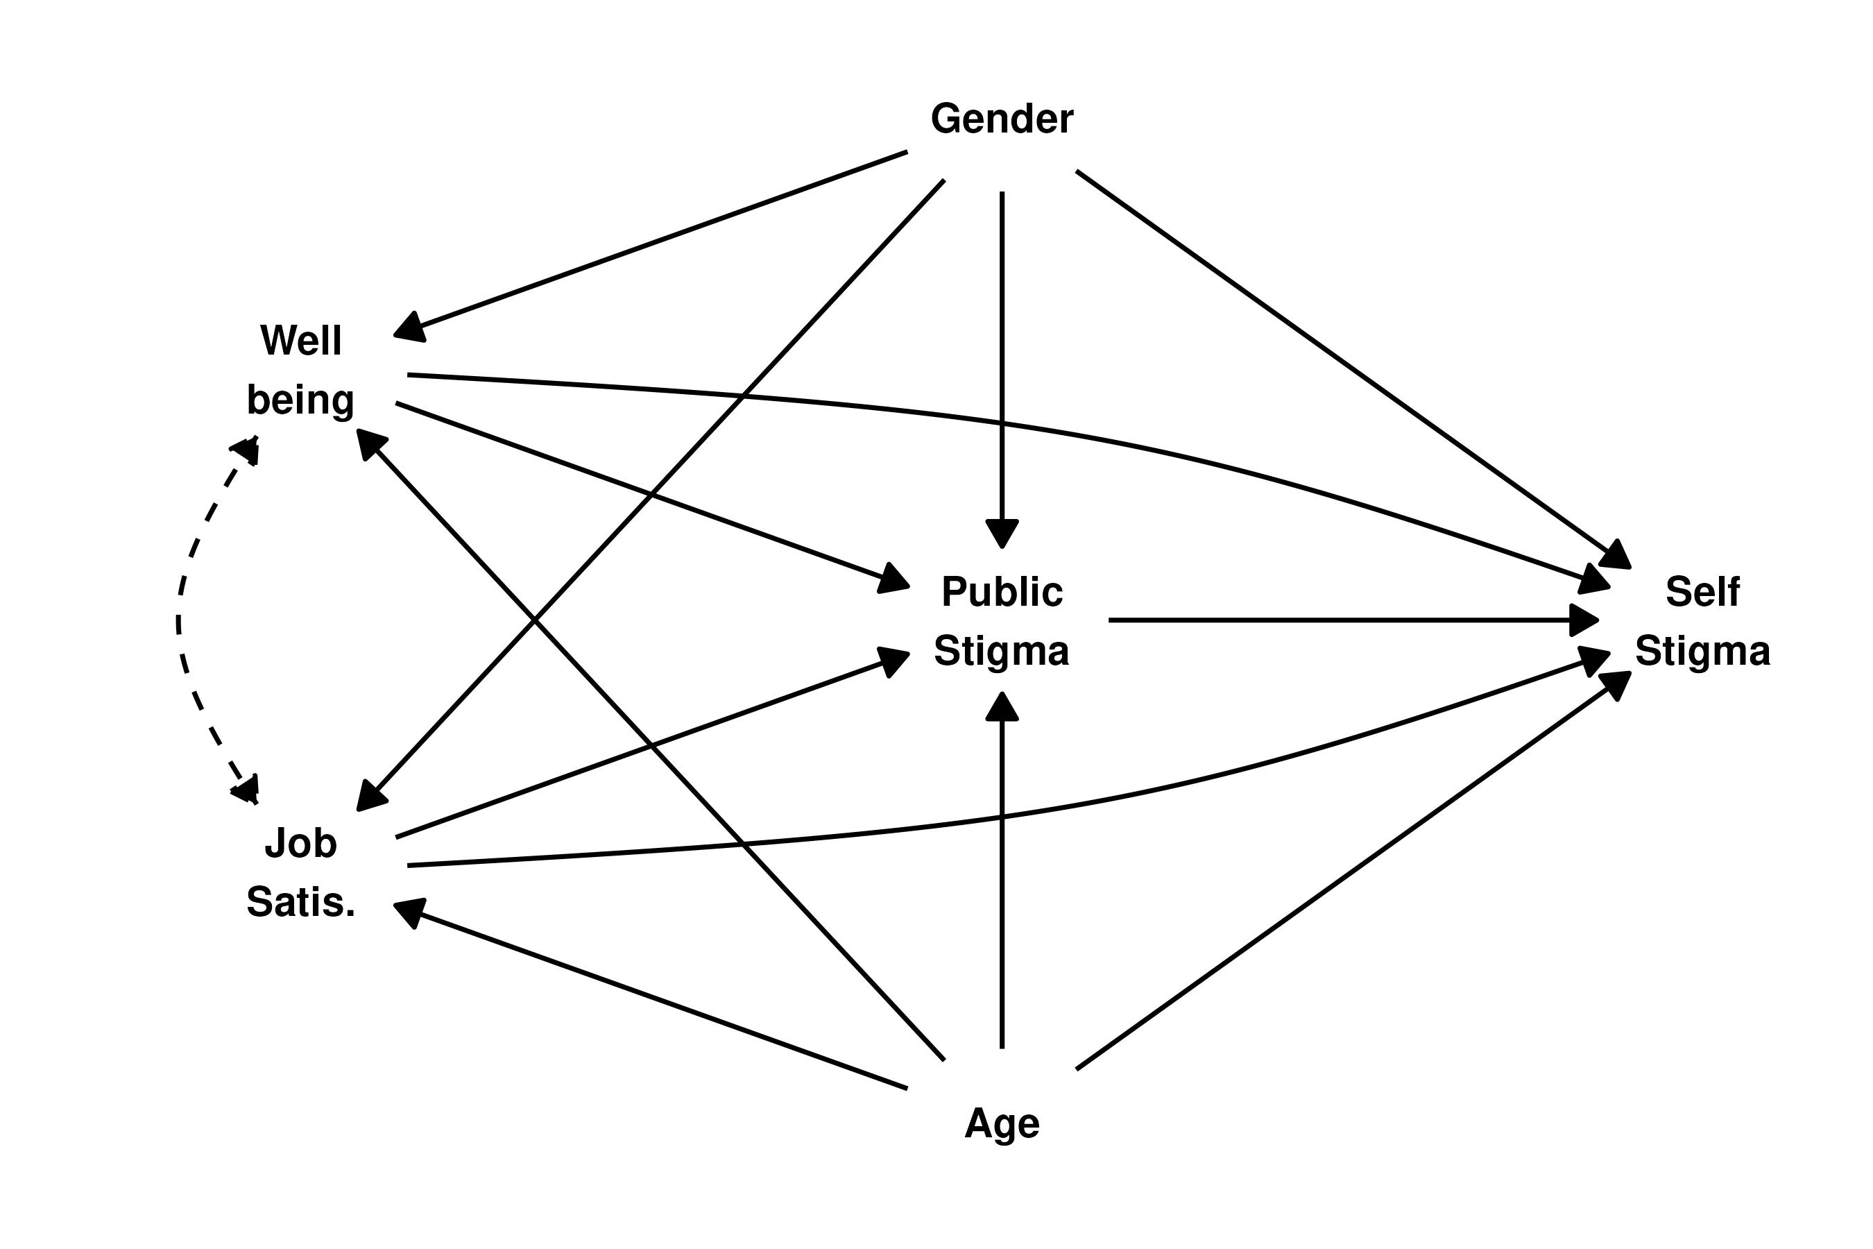

Figure 2
Causal relations between observed variables assumed by the first alternative model, in which the stigmas are causes rather than consequences of Job Satisfaction and Well being.
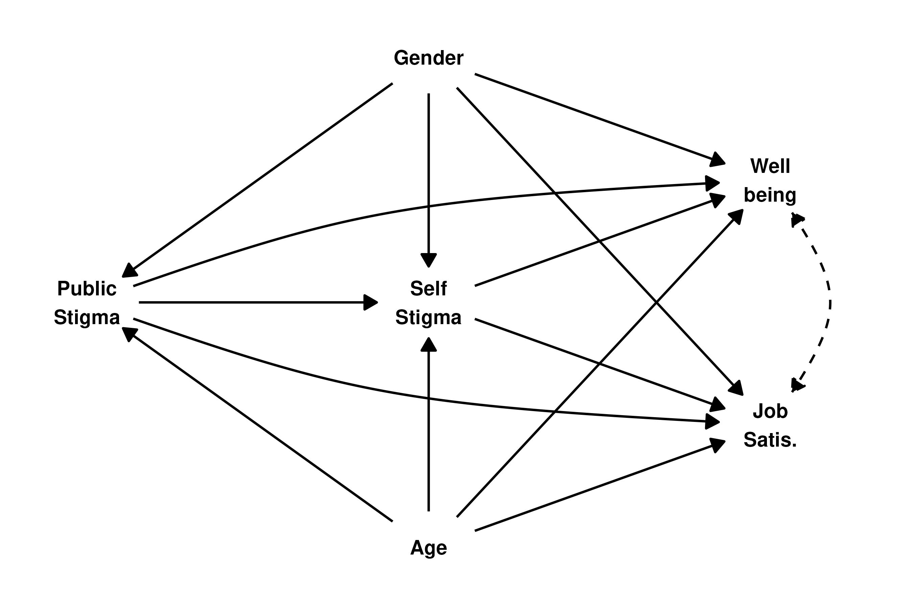

Figure 3
Causal relations between observed variables assumed by the second alternative model, in which the association between the stigmas and Job Satisfaction/Well being is due to unmeasured common causes only. Dashed bidirected edges denote such common causes.
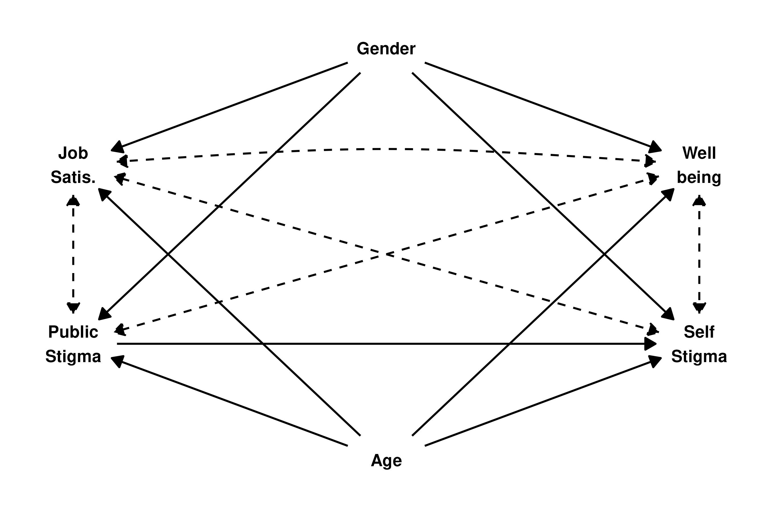

Figure 4
Psychological outcomes’ correlational structure. Green circles denote variable pairs whose correlation was statistically significant on 5% level.
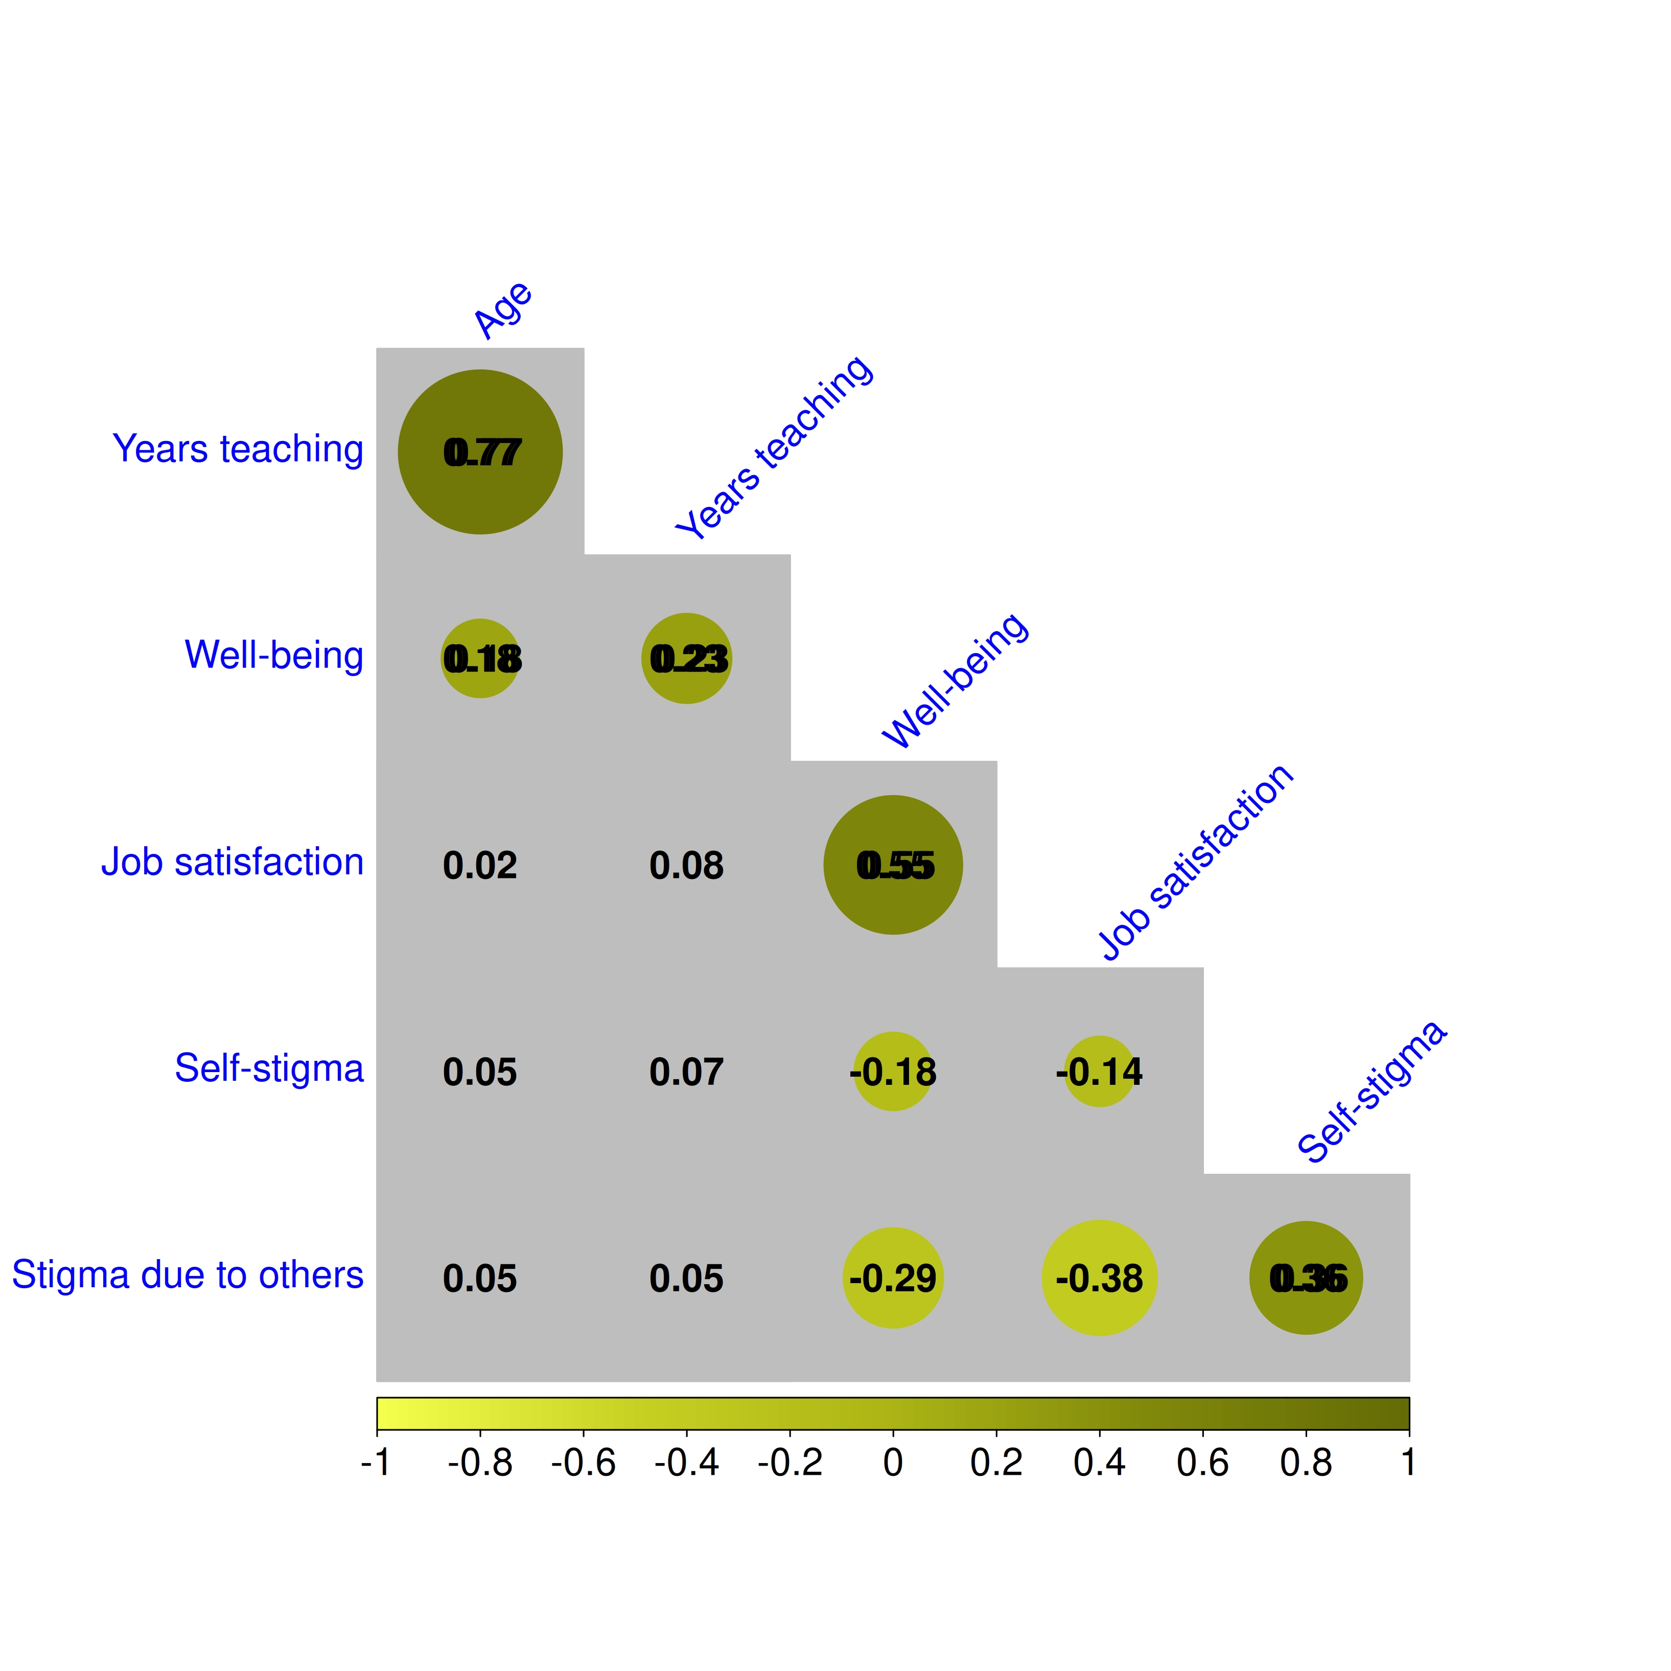

Appendix

Appendix

Table A1
Pearson’s correlations between primary outcome variables of the study
 | Age | Years teaching | Well-being | Job satisfaction | Self-stigma | Stigma due to others
Age | 1.000 (< .001)
Years teaching | .774 (< .001) | 1.000 (< .001)
Well-being | .176 (< .001) | .232 (< .001) | 1.000 (< .001)
Job satisfaction | .015 (.755) | .076 (.121) | .552 (< .001) | 1.000 (< .001)
Self-stigma | .047 (.323) | .070 (.146) | -.176 (< .001) | -.142 (.004) | 1.000 (< .001)
Stigma due to others | .054 (.264) | .050 (.296) | -.289 (< .001) | -.381 (< .001) | .365 (< .001) | 1.000 (< .001)

Figure A1
Item-level correlation matrix. Cells represent polychoric correlations between each item of each questionnaire used.
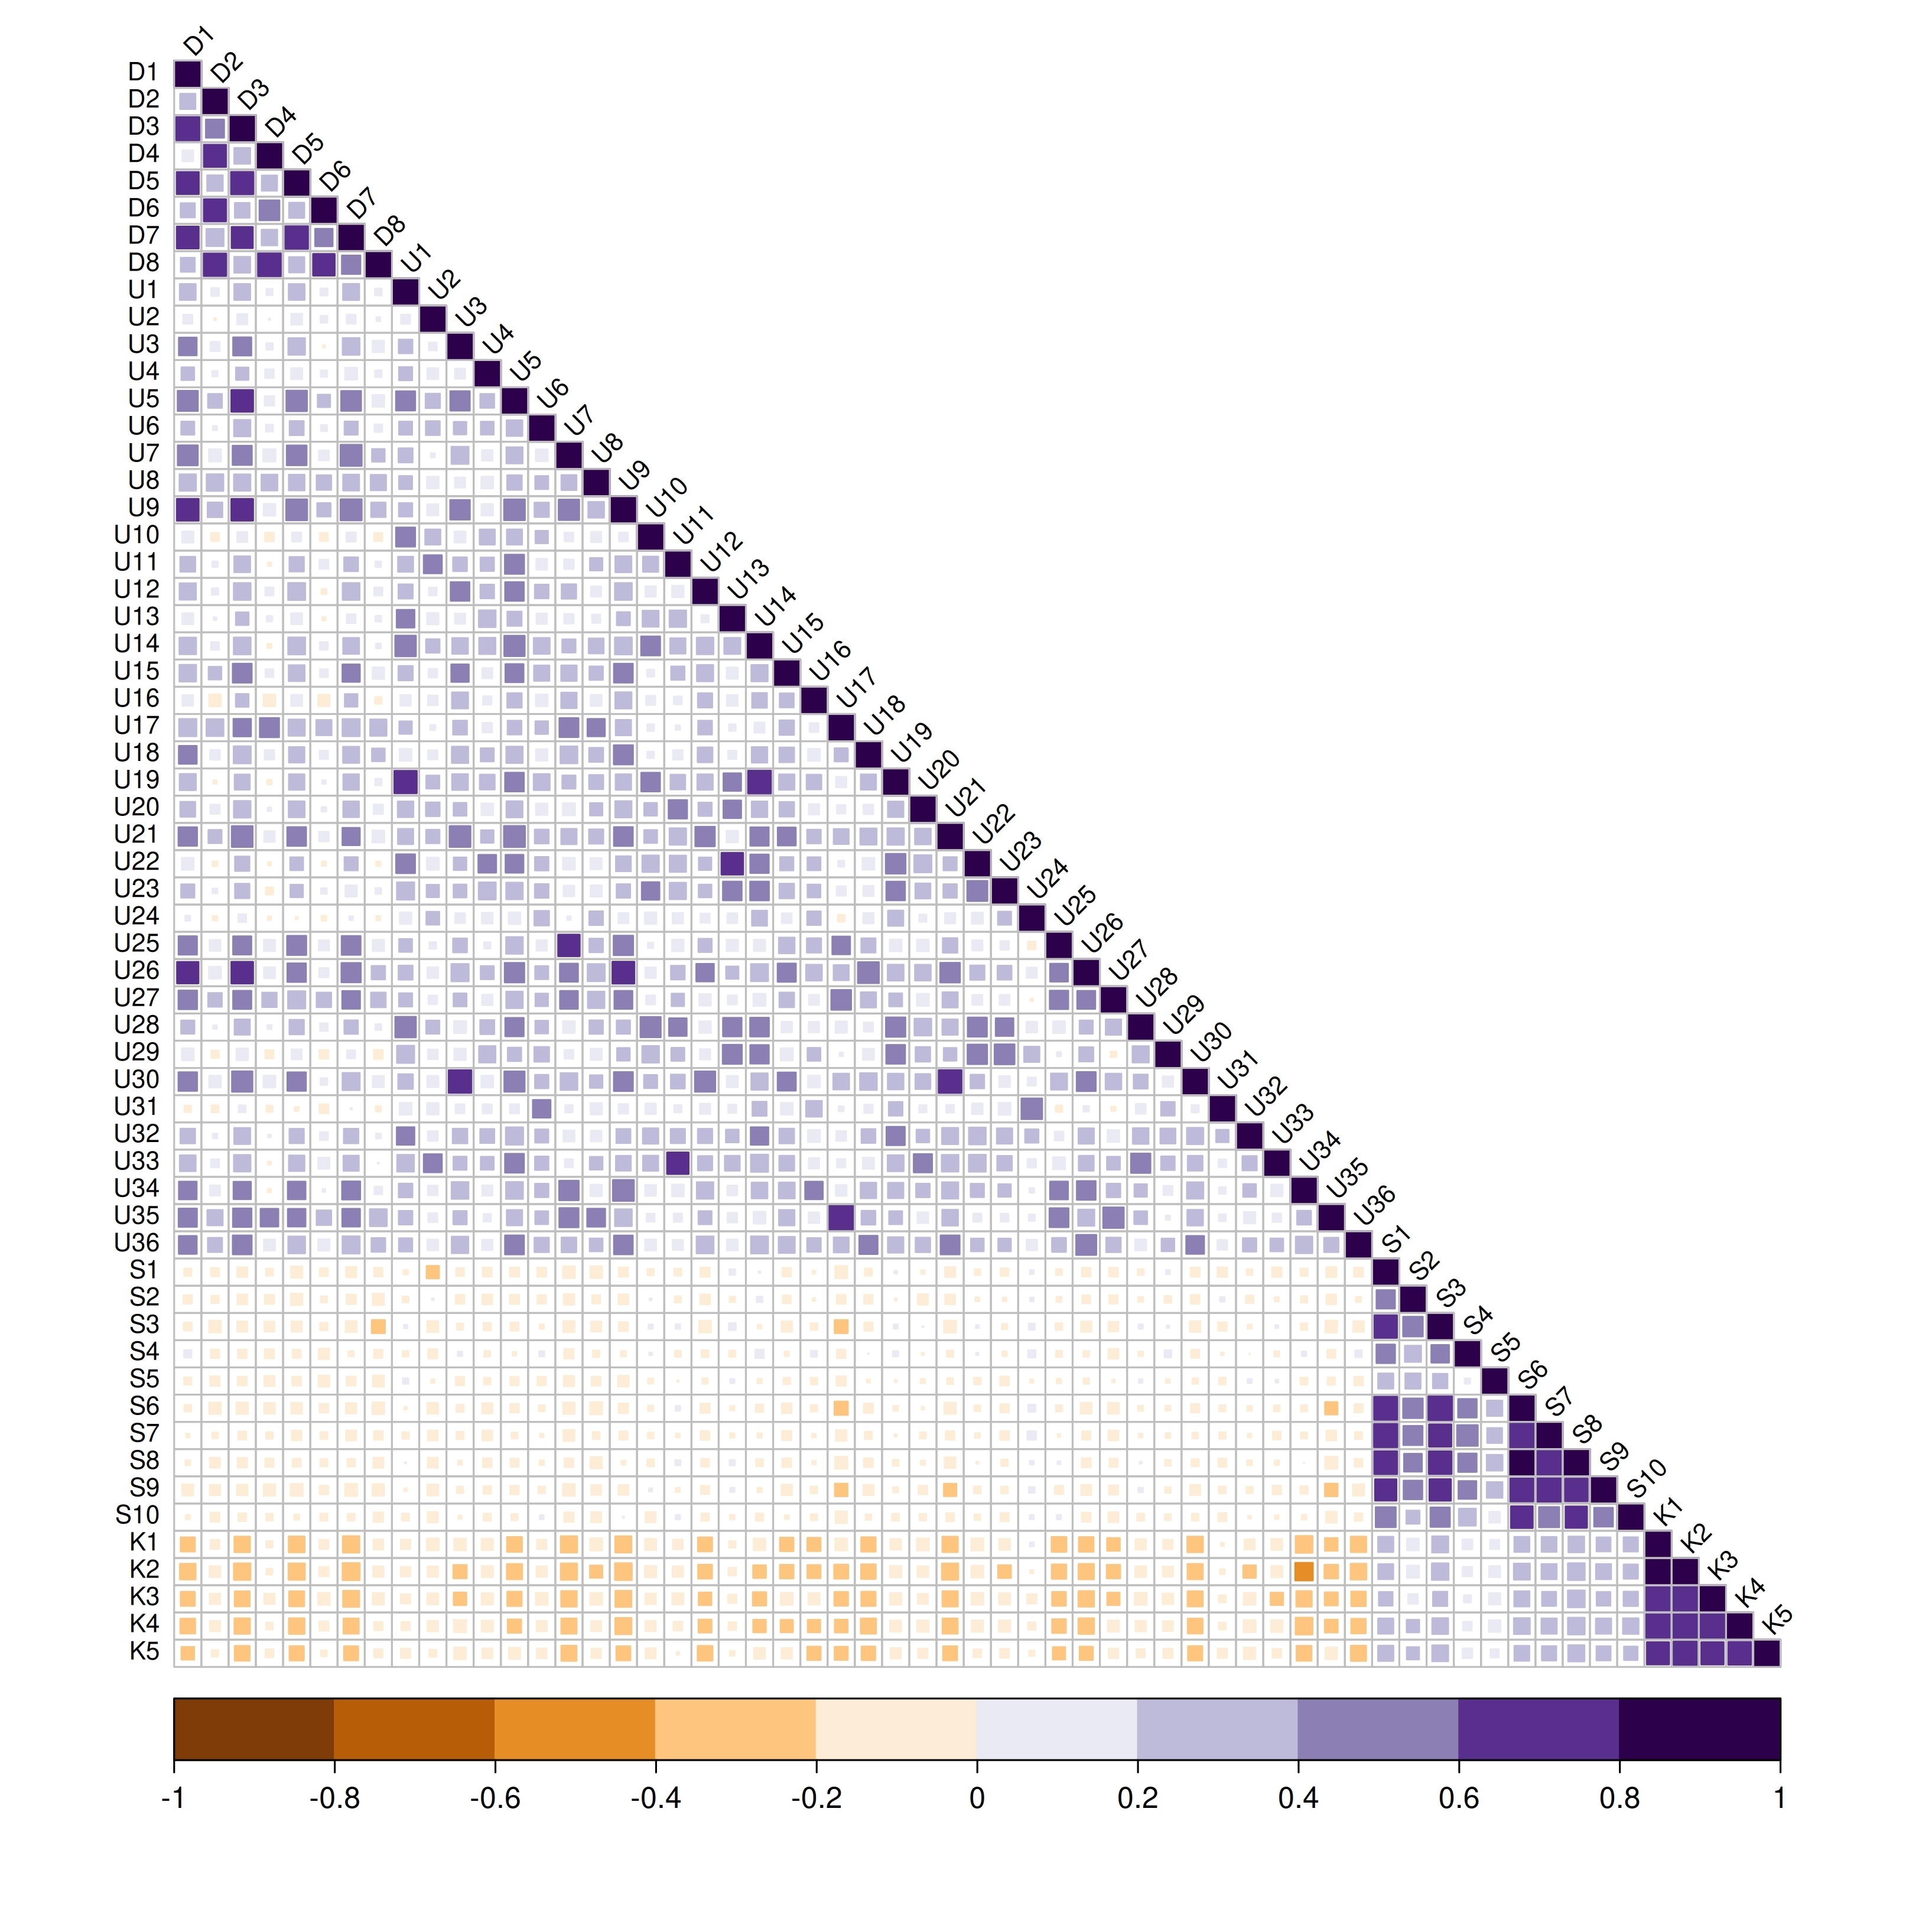

References
Cronbach, L. J. (1951). Coefficient alpha and the internal structure of tests. Psychometrika, 16(3), 297–334. https://doi.org/10.1007/bf02310555
Feldt, L. S., Woodruff, D. J., & Salih, F. A. (1987). Statistical inference for coefficient alpha. Applied Psychological Measurement, 11(1), 93–103. https://doi.org/10.1177/014662168701100107
Olsson, U. (1979). Maximum likelihood estimation of the polychoric correlation coefficient. Psychometrika, 44(4), 443–460. https://doi.org/10.1007/bf02296207
Revelle, W. (2022). Psych: Procedures for psychological, psychometric, and personality research. https://CRAN.R-project.org/package=psych
Rosseel, Y. (2012). lavaan: An R package for structural equation modeling. In Journal of Statistical Software (No. 2; Vol. 48, pp. 1–36). https://doi.org/10.18637/jss.v048.i02
Vogel, D. L., Wade, N. G., & Hackler, A. H. (2007). Perceived social network stigma and the willingness to seek counseling: The mediating roles of self-stigma and attitudes toward counseling. Journal of Counseling Psychology, 54(1), 40–50. https://doi.org/10.1037/0022-0167.54.1.40
Wei, T., & Simko, V. (2021). R package ’corrplot’: Visualization of a correlation matrix. https://github.com/taiyun/corrplot

