Well being statistics
Josef Mana

Methods

Statistical analyses
All demographic and outcome variables were described via contingency tables for nominal (gender and education level), and ordinal (single item responses) variables and via sample mean ± standard deviation for continuous variables (age, years of teaching experience and questionnaires’ sum scores). All descriptive statistics were computed separately for each city size. Furthermore, null distributions of nominal and ordinal variables across city sizes were tested via Pearson’s $χ^{2}$ test of the null hypothesis that the joint distribution of the cell counts is the product of the row and column marginals. The null hypotheses of zero difference between means of continuous variables across city sizes as well as across education levels were tested via one-way ANOVAs with Type I sum of squares. The null hypotheses of zero difference between means of continuous variables in men and women were tested via two sample t-test with Welch approximation of degrees of freedom and two-sided alternative hypothesis.
To establish internal consistency of methods used, Cronbach’s coefficient $α$ (Cronbach 1951) was computed together with its 95% confidence interval (CI) via Feldt et al. (1987) procedure. Methods were considered to show adequate internal consistency if the $α$ exceeded 0.80.
Inspired by the model proposed by Vogel et al. (2007), we conducted a moderated mediation analysis of the effect of Well being and Job Satisfaction on Self Stigma either directly or via the Public Stigma. Specifically, we assumed that Well being and Job Satisfaction are causes of Public Stigma perception which in turn is a cause of Self Stigma perception. Moreover, we assume Well being and Job Satisfaction have a direct causal effect on Self Stigma perception and that all these relations are moderated by age and gender. Finally, Well being and Job Satisfaction were assumed to have common unobserved causes. These causal assumptions are depicted in Figure 1 in the form of a directed acyclic graph (DAG). To estimate the direct and indirect effects implied by this DAG, a structural equation model (SEM) following Figure 1 was fitted and evaluated via the lavaan (Rosseel 2012) R package. Full model specification is available at https://github.com/josefmana/StigHelp.git.
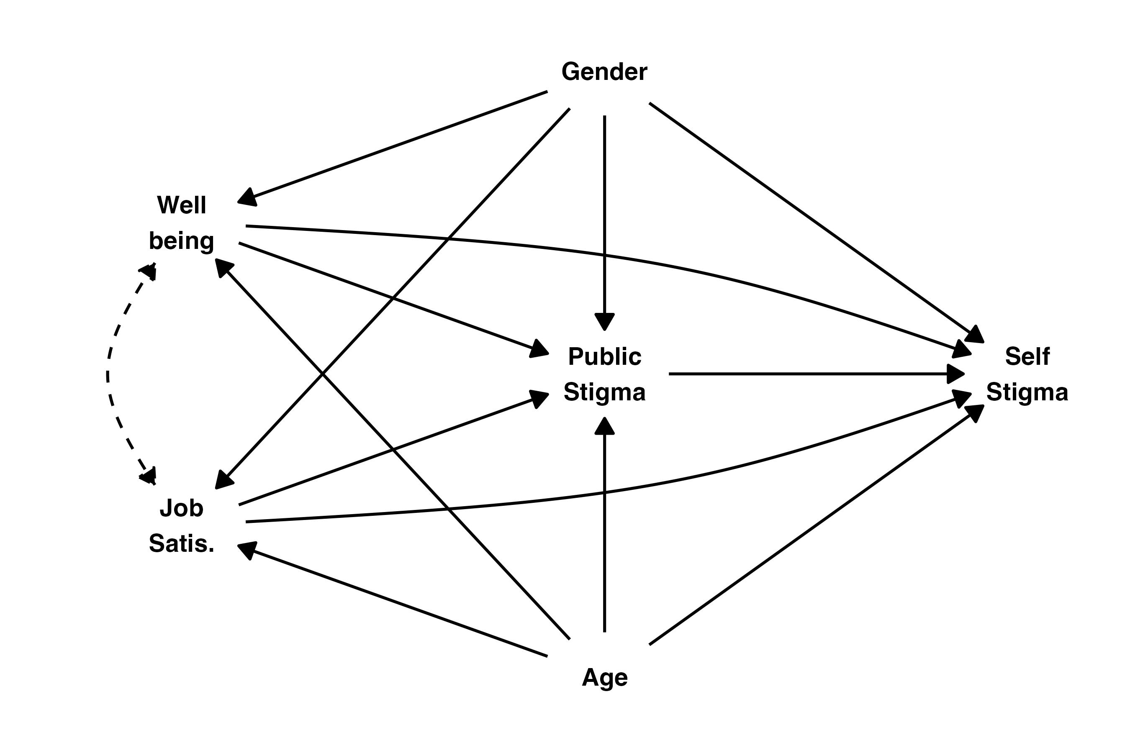
Figure 1: Assumed causal relations between observed variables represented by a directed acyclic graph.
Finally, correlation structure of questionnaires on levels of sum scores and single items was explored. For item-level analysis, all reverse-coded items were rescored such that higher scores of all items within a questionnaire implied higher level of construct being measured, and then pairwise correlation of all item pairs across all questionnaires were estimated via polychoric correlation coefficient (Olsson 1979). Sum scores’ correlations were estimated via Pearson’s correlation coefficient and null hypotheses of r = 0 were tested via t-test based on formula
$t=\frac{r\sqrt{(}n−2)}{\sqrt{(}1−r^{2})}$​
with standard error:
$se=\sqrt{(}\frac{1−r^{2}}{n−2})$,
where r = Pearson’s correlation coefficient and n = sample size.
Across analyses, missing values were addressed via complete cases analysis and tests with p < .05 were considered “statically significant.” Analyses were conducted in language for statistical computing R (version 4.6.1) via “psych” package (Revelle 2022), and correlation matrices were visualised via “corrplot” package (Wei and Simko 2021).

Results

Sample description
In total, the sample included 438 participants out of which 63 came from a city with less than 3,000 inhabitants, 159 came from a city with 3,000-15,000 inhabitants, 83 came from a city with 15,000-50,000 inhabitants, 40 came from a city with 50,000-100,000 inhabitants, 38 came from a city with 100,000-500,000 inhabitants, and 55 came from a city with more than 500,000 inhabitants. No statistically significant difference in distribution of nominal variables or means of continuous variables between city sizes was observed (Table 1).
Table 1: Sample description
 | Number of inhabitants
 | < 3,000 | 3,000 - 15,000 | 15,000 - 50,000 | 50,000 - 100,000 | 100,000 - 500,000 | > 500,000 | Statistical analysis
Demographic variables
Gender¹ | 52/11/0 | 130/27/2 | 64/18/1 | 35/4/1 | 26/11/1 | 46/9/0 | chisq(10) = 8.611, p = .569
Education level² | 3/2/58/0 | 2/7/146/4 | 3/4/71/5 | 2/1/35/2 | 2/1/31/4 | 3/2/47/3 | chisq(15) = 13.659, p = .552
Age (years) | 47.62 ± 9.03 | 47.89 ± 9.83 | 49.78 ± 10.04 | 47.42 ± 10.19 | 49.08 ± 9.33 | 48.13 ± 10.29 | F(5,430) = 0.605, p = .696
Teaching experience (years) | 21.17 ± 10.73 | 21.18 ± 11.10 | 21.78 ± 12.49 | 20.02 ± 11.38 | 20.87 ± 11.15 | 17.55 ± 12.19 | F(5,429) = 1.080, p = .371
Psychological outcomes
Well-being (D scale) | 26.43 ± 3.87 | 25.96 ± 3.48 | 25.75 ± 3.71 | 26.02 ± 3.77 | 26.18 ± 3.65 | 26.55 ± 3.43 | F(5,432) = 0.482, p = .790
Job satisfaction (U scale) | 136.89 ± 29.76 | 136.21 ± 23.44 | 132.85 ± 25.44 | 138.85 ± 26.81 | 125.46 ± 28.90 | 139.20 ± 24.14 | F(5,413) = 1.651, p = .145
Self-stigma (S scale) | 23.49 ± 7.98 | 23.21 ± 7.06 | 23.35 ± 7.95 | 22.38 ± 7.08 | 21.84 ± 6.86 | 22.16 ± 7.81 | F(5,432) = 0.491, p = .783
Stigma due to others (K scale) | 10.05 ± 3.73 | 10.65 ± 4.21 | 10.06 ± 3.44 | 9.35 ± 3.79 | 10.55 ± 3.18 | 10.15 ± 3.94 | F(5,432) = 0.905, p = .478
¹presented as women/men/unanswered
²presented as High school/Bachelors/Masters/PhD
All continuous variables are reported as sample mean ± standard deviation.
There were 17 participants with High School, 15 participants with Bachelor’s degree, 388 participants with Master’s degree, and 18 participants with PhD. We did not observe any statistically significant differences in means of psychological outcomes between different education levels (Table 2).
Table 2: Psychological outcomes’ means across education level
 | Education level
 | High school | BA | MA | PhD | One-way ANOVA
Well-being (D scale) | 24.24 ± 3.96 | 26.40 ± 2.90 | 26.13 ± 3.58 | 26.56 ± 4.19 | F(3,434) = 1.663, p = .174
Job satisfaction (U scale) | 137.07 ± 23.77 | 128.50 ± 22.03 | 135.91 ± 25.86 | 128.41 ± 29.37 | F(3,415) = 0.817, p = .485
Self-stigma (S scale) | 22.59 ± 7.58 | 23.33 ± 8.53 | 22.97 ± 7.45 | 22.44 ± 6.46 | F(3,434) = 0.056, p = .983
Stigma due to others (K scale) | 10.12 ± 2.87 | 10.60 ± 4.85 | 10.17 ± 3.81 | 12.00 ± 4.39 | F(3,434) = 1.341, p = .260
BA = Bachelor's degree, MA = Master's degree. All variables are reported as sample mean ± standard deviation
There were 353 women, 80 men, and 5 participants who did not report their gender. We observed a statistically significant difference between mean Self Stigma ($M_{women}$ = 22.25, $M_{men}$ = 25.86, t(131.25) = -4.382, p < .001) and mean Public stigma ($M_{women}$ = 10.01, $M_{men}$ = 11.31, t(117.94) = -2.766, p = .007). In both cases, men reported higher mean stigmatisation compared to women. We did not observe a significant difference between men and women in either mean Well-being ($M_{women}$ = 26.03, $M_{men}$ = 26.40, t(126.44) = -0.885, p = .378) or mean Job satisfaction ($M_{women}$ = 135.84, $M_{men}$ = 134.69, t(110.01) = 0.355, p = .723).

Internal consistency
All scales showed adequate internal consistency in the current sample according to the Cronbach’s $α$ estimates ($α_{D}$ = 0.82, 95% CI [0.80,0.85], $α_{U}$ = 0.92, 95% CI [0.91,0.93], $α_{S}$ = 0.89, 95% CI [0.87,0.90], $α_{K}$ = 0.92, 95% CI [0.91,0.93]) for Well being, Job satisfaction, Self-stigma and Public stigma respectively.

Moderated mediation
Effect estimates from the SEM are presented in Table 3. We observed a statistically significant effect of Public Stigma on Self Stigma across age groups and genders. The model implies a significant effect of Job Satisfaction and Well being on Public Stigma in Women. The estimates of total effect of Job Satisfaction on Self-Stigma were compatible with a null model (i.e., no causal effect). On the other hand, the model implies a statistically significant total effect of Well being on Self-stigma in women, especially in older age groups. This effect was driven primarily by the direct effect instead of the indirect effect via Public Stigma.
Table 3: Effects derived from the structural equation model of observed variables
 | 38 years old |  | 48 years old |  | 58 years old
 | Male | Female | Male | Female | Male | Female
Self Stigma - Job Satisfaction
Total effect | -0.24 [-0.70, 0.07] | -0.13 [-0.36, 0.12] | -0.15 [-0.51, 0.07] | -0.04 [-0.17, 0.11] | -0.04 [-0.36, 0.16] | 0.08 [-0.06, 0.23]
Direct effect | -0.18 [-0.58, 0.12] | -0.04 [-0.26, 0.18] | -0.07 [-0.42, 0.14] | 0.07 [-0.06, 0.19] | 0.03 [-0.27, 0.22] | 0.17 [-0.00, 0.33]*
Indirect effect | -0.06 [-0.28, 0.05] | -0.10 [-0.19, -0.02]* | -0.07 [-0.24, -0.00] | -0.10 [-0.16, -0.06]*** | -0.07 [-0.21, 0.01] | -0.10 [-0.18, -0.03]**
Self Stigma - Well being
Total effect | 0.06 [-0.20, 0.45] | -0.16 [-0.37, 0.02] | 0.05 [-0.19, 0.37] | -0.17 [-0.29, -0.05]** | 0.01 [-0.25, 0.29] | -0.21 [-0.35, -0.10]***
Direct effect | 0.20 [-0.01, 0.57] | -0.04 [-0.24, 0.14] | 0.12 [-0.11, 0.43] | -0.12 [-0.24, -0.00]* | 0.04 [-0.23, 0.31] | -0.20 [-0.36, -0.09]**
Indirect effect | -0.14 [-0.32, -0.01] | -0.12 [-0.23, -0.05]** | -0.07 [-0.18, 0.01] | -0.05 [-0.12, -0.00] | -0.03 [-0.12, 0.07] | -0.01 [-0.07, 0.03]
Self Stigma - Public Stigma
Direct effect | 0.41 [0.16, 0.72]** | 0.45 [0.26, 0.61]*** | 0.31 [0.08, 0.60]* | 0.36 [0.20, 0.48]*** | 0.22 [-0.03, 0.46] | 0.27 [0.07, 0.43]***
Public Stigma - Job Satisfaction
Direct effect | -0.16 [-0.55, 0.13] | -0.21 [-0.43, -0.04]* | -0.24 [-0.57, -0.02] | -0.29 [-0.43, -0.18]*** | -0.31 [-0.69, -0.12]* | -0.37 [-0.52, -0.20]***
Public Stigma - Well being
Direct effect | -0.35 [-0.60, -0.07]* | -0.27 [-0.43, -0.12]** | -0.24 [-0.49, 0.04] | -0.15 [-0.28, -0.00]* | -0.12 [-0.40, 0.18] | -0.04 [-0.20, 0.16]
The table shows estimates of the structural equation model estimating moderated mediation model represented in Figure XX. Values are (transformations of) model parameters with their 95% confidence intervals from the bootstrap percentile interval estimated by R function boot::boot.ci(). Mediation effects are estimated for 'Outcome - Predictor' pairs at different levels of moderators Gender (male vs. female) and Age (mean, 48 years old, as well as plus/minus in-sample standard deviation). Statistical tests of the parameters being equal to zero were tested by a z-test implemented in the lavaan R package. *p < .05, **p < .01, ***p < .001.

Correlation structure
Correlation matrix of sum scores is presented in Figure 2 (see also Table 4 for numeric representation). Both Self-stigma and Stigma due to others correlated statistically significantly with Well-being and Job satisfaction but not with age and years of teaching experience. Interestingly, the correlation seems to be confined to several stigma due to others scale items on the item-level (see Figure 3)
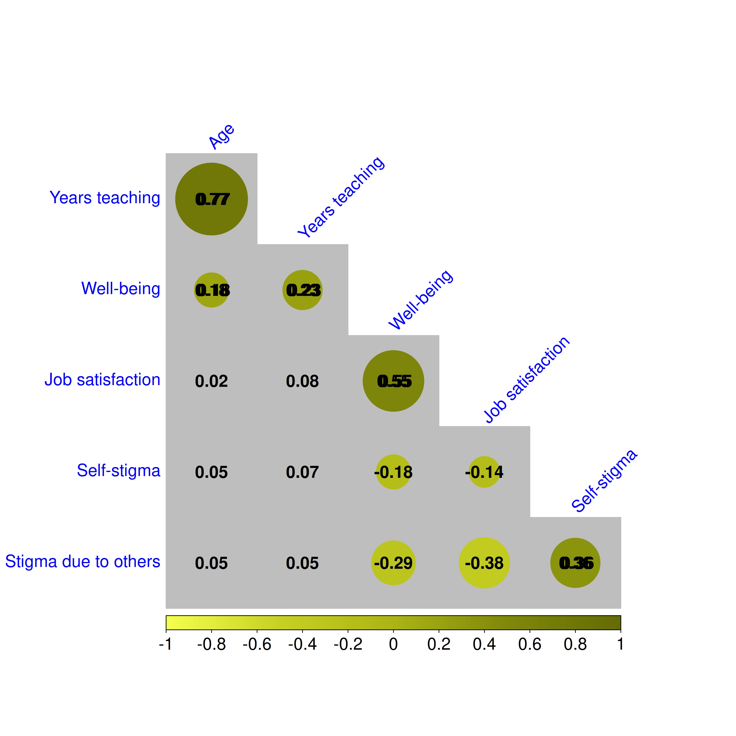
Figure 2: Psychological outcomes’ correlational structure. Green circles denote variable pairs whose correlation was statistically significant on 5% level.

Appendix
Table 4: Pearson’s correlations between primary outcome variables of the study
 | Age | Years teaching | Well-being | Job satisfaction | Self-stigma | Stigma due to others
Age | 1.000 (< .001)
Years teaching | .774 (< .001) | 1.000 (< .001)
Well-being | .176 (< .001) | .232 (< .001) | 1.000 (< .001)
Job satisfaction | .015 (.755) | .076 (.121) | .552 (< .001) | 1.000 (< .001)
Self-stigma | .047 (.323) | .070 (.146) | -.176 (< .001) | -.142 (.004) | 1.000 (< .001)
Stigma due to others | .054 (.264) | .050 (.296) | -.289 (< .001) | -.381 (< .001) | .365 (< .001) | 1.000 (< .001)
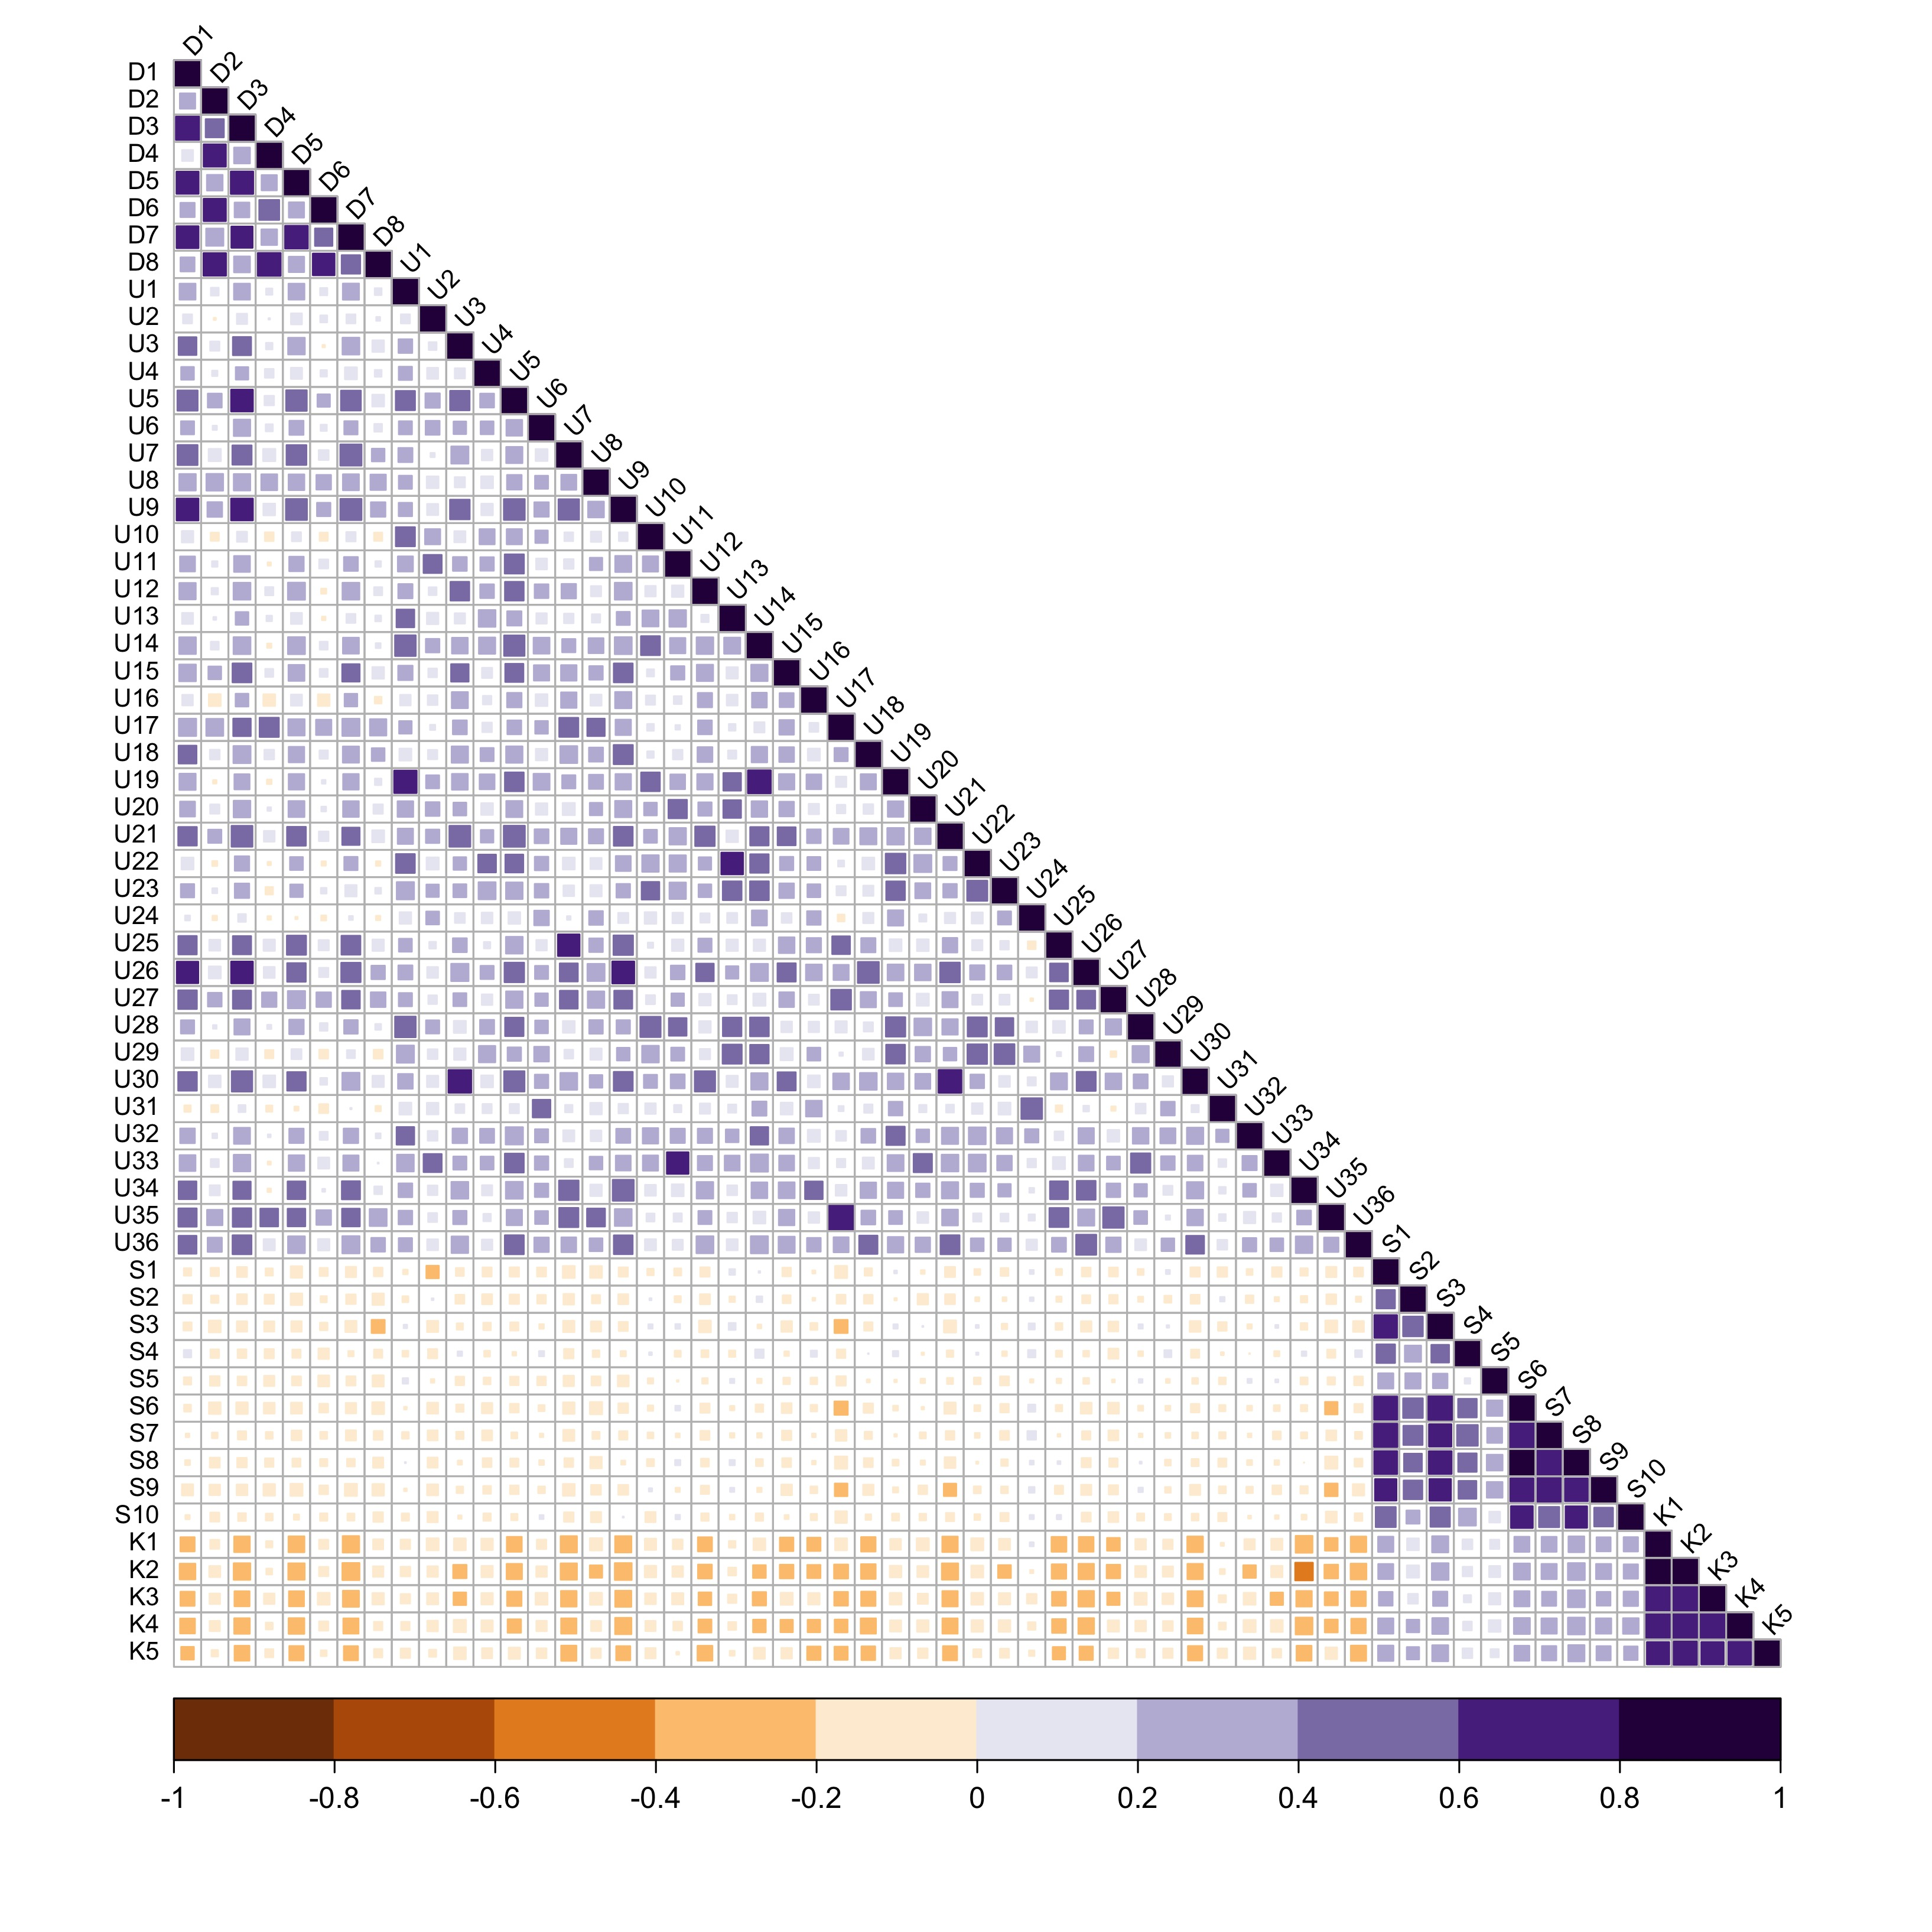
Figure 3: Item-level correlation matrix. Cells represent polychoric correlations between each item of each questionnaire used.

References
Cronbach, Lee J. 1951. “Coefficient Alpha and the Internal Structure of Tests.” Psychometrika 16 (3): 297–334. https://doi.org/10.1007/bf02310555.
Feldt, Leonard S., David J. Woodruff, and Fathi A. Salih. 1987. “Statistical Inference for Coefficient Alpha.” Applied Psychological Measurement 11 (1): 93–103. https://doi.org/10.1177/014662168701100107.
Olsson, Ulf. 1979. “Maximum Likelihood Estimation of the Polychoric Correlation Coefficient.” Psychometrika 44 (4): 443–60. https://doi.org/10.1007/bf02296207.
Revelle, William. 2022. Psych: Procedures for Psychological, Psychometric, and Personality Research. https://CRAN.R-project.org/package=psych.
Rosseel, Yves. 2012. “lavaan: An R Package for Structural Equation Modeling.” In Journal of Statistical Software, No. 2, vol. 48. https://doi.org/10.18637/jss.v048.i02.
Vogel, David L., Nathaniel G. Wade, and Ashley H. Hackler. 2007. “Perceived Public Stigma and the Willingness to Seek Counseling: The Mediating Roles of Self-Stigma and Attitudes Toward Counseling.” Journal of Counseling Psychology 54 (1): 40–50. https://doi.org/10.1037/0022-0167.54.1.40.
Wei, Taiyun, and Viliam Simko. 2021. R Package ’Corrplot’: Visualization of a Correlation Matrix. https://github.com/taiyun/corrplot.

